Physical Education
PE is taught progressively through the 3 strands of ‘motor competence’, ‘rules, strategies and tactics’ and ‘healthy participation’. Each of these strands is developed through the following key areas of learning:
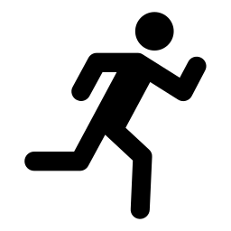 | 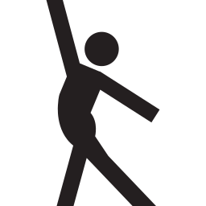 | 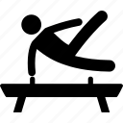 | 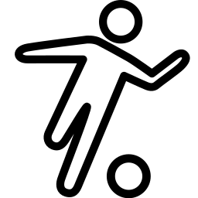 | 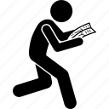 | 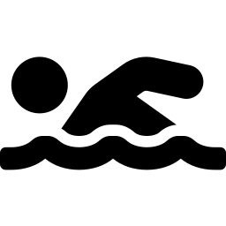
Athletics | Dance and movement | Gymnastics | Team games | Outdoor adventurous activities | Swimming

Key concepts (Big Ideas) in Physical Education
Pupils will develop the knowledge and skills needed to excel in a broad range of physical activities, including regular engagement in competitive sports and activities. Alongside this, PE lessons will ensure pupils are physically active for sustained periods of times and develop their understanding of how to live healthy, active lives.
Through different units of work we develop:
- Motor competence: developing and refining the movements needed for different activities, including flexible knowledge (throwing, running) which can be applied across different activities
- Rules, strategies and tactics: these apply to specific sports and games but also flexible knowledge eg: the need for tactics and strategy
- Healthy participation: the positive contribution that regular physical activity can make to physical and mental health and how to participate safely eg: warm ups
They will develop their abilities in performance by using their knowledge of motor competence. They will develop their creativity by exploring and experimenting with techniques and tactics and learn how to evaluate and analyse games and performances.
In all units of work, pupils will be taught
- Declarative knowledge eg: knowing how to perform movements or actions, knowing rules, strategies and tactics for the activity
- Procedural knowledge eg: knowing how to apply their knowledge to sequences, routines or games
Athletics
Pupils will develop increasing competence in the techniques of running, jumping, throwing and catching.

Dance and movement
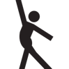
Pupils will learn how to move in different ways and use this to develop sequences. They will become increasingly skilled in communicating ideas through dance and movement, respond to rhythm and apply their learning to performance.

Gymnastics
Pupils will learn and practice skills relating to balance, shape, travelling, flexibility, strength and control. They will gain the knowledge of different gymnastic moves and use these to create sequences with increasing competence and complexity.

Team games
Pupils will develop and apply a range of skills including passing, fielding, dribbling, shooting, attaching and defending in a variety of team games, including competitive games. They will take part in striking and fielding games such as cricket and rounders, invasion games such as football, netball and hockey, and net & wall games such as tennis, badminton and table tennis).
Outdoor adventurous activities
Pupils will learn the importance of teamwork and communication when solving outdoor adventurous problems involving orientation, navigation, maps and compasses.

Swimming
Pupils will develop an understanding of water safety, learn different strokes for swimming and increase their confidence in water. They will learn to swim competently and proficiently over a distance of 25 metres.

Knowledge and skills sequencing |  |  |  | PHYSICAL EDUCATION
 |  | EYFS | Y1 |  | Y2 | Y3 | Y4 |  | Y5 | Y6
Athletics  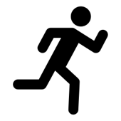  Motor competence  Rules, strategies and tactics |  | To learn the fundamental movement skills: rolling, crawling, walking, jumping, running, hopping, skipping, climbing | To be able to move by running and jumping with control and care  To be able to explore throwing and catching using a range of techniques |  | To master basic throwing and catching.  To master basic running and jumping | To show control, accuracy and coordination within running and jumping movements at different speeds  To be able to take part in a relay, remembering when to run and how to work within a team | To be able to run over a long distance and sprint a short distance and understand the different techniques needed  To be able to throw in different ways and hit a target  To be able to jump in different ways  To know the rules and tactics needed for different athletic activities |  | To be able to control my body when taking off and landing  To be able to throw with accuracy  To know the rules and tactics needed for a wider range of athletic activities | To be able to combine a range of running, jumping, throwing and catching techniques with control.  To know the rules and tactics needed for a wider range of athletic activities
Dance and movement  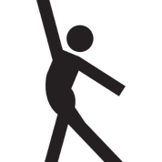  Motor competence  Rules, strategies and tactics |  | To progress towards a more fluent style of moving, with developing control and grace | To be able to copy, learn and perform some dance moves |  | To be able to change rhythm, speed, level and direction in my dance  To be able dance with some control and coordination  To be able to perform dances using simple movement patterns | To be able to improvise freely and translate ideas from a stimulus into movement  To be able to share and create phrases with a partner and small group  To be able to repeat, remember and perform phrases | To be able to use dance to communicate an idea through a range of movements and patterns |  | To be able to perform a dance which shows clarity, fluency, accuracy and consistency  To be able to perform to an accompaniment  To be able to compose my own dances in a creative ways | To be able to develop sequences in a specific style  To be able to perform dances using simple movement patterns  To be able to choose my own music and style
 |  | EYFS | Y1 |  | Y2 | Y3 | Y4 |  | Y5 | Y6
Team Games  Team Games  (Cont..) | (Striking and fielding)  Motor competence  Rules, strategies and tactics | To develop and refine a range of ball skills including: throwing, catching, kicking, passing, batting and aiming | To be able to move and stop safely  To be able to throw underarm  To begin to catch more consistently  To be able to strike with a racket or bat |  | To be able to send and receive  To be able to decide the best space to be in during a game  To be able to follow rules  To use hand-eye coordination to control a ball  To be able to catch a variety of objects | To be able to throw and catch with control  To be aware of space and use it to support team-mates and to cause problems for the opposition  To know and use rules fairly | To be able to catch with one hand  To be able to hit, bowl, throw and catch with increasing accuracy  To be able to vary my tactics and adapt my skills depending on what is happening in a game |  | To be able to hit, throw, bowl and catch accurately and with control  To be able to use a range of techniques when fielding | To be able to use a range of techniques with confidence and skill in a game situation  To be able to play competitive games to agreed rules  To be able to explain rules to others  To be able to communicate a plan to my team
 | (Invasion)  Motor competence  Rules, strategies and tactics | To be able to combine different movements with ease and fluency | To be able to move and stop safely  To be able to throw and kick in different ways  To be able to stop a ball |  | To be able to throw, hit or kick a ball with increasing accuracy  To be able to decide the best space to be in during a game  To be able to use tactics in a game when attacking and defending  To be able to follow rules | To be able to throw, hit or kick a ball with accuracy  To be aware of space and use it to support team-mates and to cause problems for the opposition  To know and use rules fairly | To be able to pass, throw and catch accurately with control  To be able to keep possession of the ball  To be able to vary my tactics and adapt my skills depending on what is happening in a game |  | To be able to pass in different ways  To be able to choose a tactic for defending and attacking  To be able to use a number of techniques to pass, dribble and shoot  To be able to gain possession by working as part of a team | To be able to use a number of techniques to pass, dribble and shoot with control and accuracy  To be able to apply basic principles suitable for attacking and defending  To be able to play competitive games to agreed rules  To be able to explain rules to others  To be able to communicate a plan to my team
 | (Net / Wall)  Motor competence  Rules, strategies and tactics |  |  |  |  | To be able to throw and catch with control  To be able to serve underarm  To be able to build up a rally | To be able to play a variety of shots  To demonstrate and use the correct grip on a racket  To develop greater accuracy of strokes  To know the rules for a net game |  | To develop techniques for ground strokes and volleys  To develop a backhand technique and use it in a game  To be able to serve overarm  To know when to use different shots | To use good hand/eye co-ordination when playing and serving  To know where a shot should be aimed and show increasing accuracy  To use different shots in a game situation to outwit an opponent
 |  | EYFS | Y1 |  | Y2 | Y3 | Y4 |  | Y5 | Y6
Gymnastics  Motor competence  Rules, strategies and tactics |  | To develop overall body-strength, balance, co-ordination and agility | To be able to make my body curled, tense, stretched and relaxed  To be able to control my body when travelling and balancing in different ways |  | To be able to use balance, agility and coordination in a range of activities  To be able to plan and perform a sequence of coordinated movements including a balance | To be able to explain how strength and suppleness affect performance  To be able to compare and contrast gymnastic sequences  To adapt sequences to suit different types of apparatus and criteria | To include change of speed and direction with control  To include a range of shapes in a sequence  To be able to work with a partner to create, repeat and improve a sequence with at least three phases |  | To combine action, balance and shape  To perform consistently to different audiences  To be able to make complex extended sequences | To be able to demonstrate flexibility, strength, control and balance in a sequence of movements  To develop technical sequences in a specific style

 | EYFS | Y1 | Y2 | Y3 | Y4 | Y5 | Y6
Outdoor adventurous activities  Motor competence  Rules, strategies and tactics |  |  |  | To be able to follow a map in a familiar context  To be able to use clues to follow a route safely | To be able to work in a team and individually to use a map and solve problems with greater confidence and can identify risks whilst advising others  To be able to follow a route within a time limit | To confidently orientate myself and others to solve problems in unfamiliar environments  Follow a map into an unknown location  Use clues and a compass to navigate a route | To be able to plan route and a series of clues for someone else  To be able to take part in outdoor and adventurous activity challenges both individually and in a team
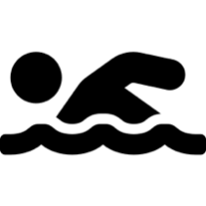  Swimming |  |  |  | To be able to use a range of strokes effectively  To perform safe self-rescue in different water based situations  To swim competently, confidently and proficiently over a distance of at least 25m

Sports Science Sequencing |  |  |  | PHYSICAL EDUCATION
 | EYFS | Y1 | Y2 |  | Y3 | Y4 | Y5 | Y6
Sports Science  Motor competence  Rules, strategies and tactics  Healthy Participation |  | To know why moving my body is an important part of being healthy | To know the importance of a warm up  To explain the benefits a warm up has on our body |  | To take a pulse rate reading before and after exercise and see the impact exercise has on it  To explain why heart rates increase after exercise  To appreciate that being active is part of being healthy both physically and mentally | To explain how a warm up prepares and protects our body during physical activity (aerobic exercise to increase heart rate and warm muscles, then how to stretch safely to ensure muscle damage doesn’t occur)  To understand that being healthy physically and mentally relies on diet and physical activity | To know the names, locations and usage for some of the main muscles in the body (biceps, triceps, quadriceps, hamstring)  To begin to understand how muscles work in pairs to allow us to move. | To identify the bodies 5 major muscle groups and their names  (chest, back, arms and shoulders, abdominals, legs and buttocks)  To understand that having a healthy, active lifestyle impacts our mental health (exercise releases endorphins which reduce chance of depression and anxiety. Improve self-esteem. Regulate appetite  Provide an enhanced immune response)  To understand the short and long term effects physical exercise has on the body and mental health

LONG TERM PLAN
