PSHE
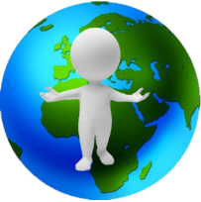 | 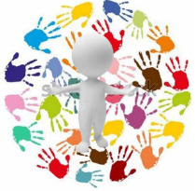 | 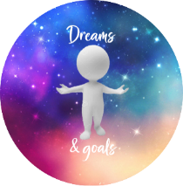 | 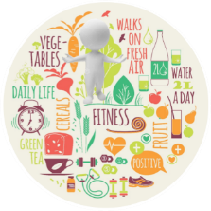 | 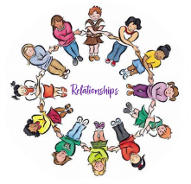 | 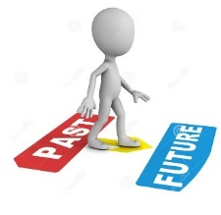
Being me in my world | Celebrating Difference | Dreams and Goals | Healthy Me | Relationships | Changing Me

Key concepts (Big Ideas) in PSHE
Pupils will develop the fundamental personal, social, health and emotional skills needed to underpin their development as people and enable them to thrive in society. Throughout the PSHE curriculum, Pupils will build a ‘toolkit’ to enable them to understand the ever changing world around them, understand how to keep themselves safe and healthy, form positive relationships, develop tolerance and understanding for others, understand their feelings, emotions and changes happening to their bodies and facilitate them to develop their own positive mental health. Within PSHE, pupils will also develop an understanding of British Values and the Protected Characteristics.

Being me in my world
Pupils will develop an understanding of children’s rights. They will learn that with rights, come responsibilities, rules and consequences. They will learn how to articulate their emotions and understand that all emotions are valid. Pupils will learn that their views are important and see how their views link to living in a democratic society and further, how their actions and personal choices can have an affect locally, within their school community and globally.

Celebrating difference
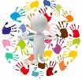
Pupils will develop and understanding how our differences make us unique and special. They will focus more in depth on naming emotions and using this to manage conflict. Pupils will learn how to be understanding and tolerant of other people’s differences, even if they don’t understand or agree with them. They will learn how conflict and not showing tolerance can lead to bullying and how to navigate away from these situations. Pupils will also be addressing
stereotypes for boys and girls and learning that they don’t need to fit stereotypes and that assumptions shouldn’t be made as they may cloud their judgement.

Dreams and goals
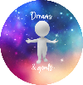
Pupils will understand what a challenge is and how this can be related to or developed into a goal. They will develop the skills to set appropriate and achievable goals while understanding the steps they need to take to be successful. They will explore a range of different careers and professions and how to be successful at obtaining their chosen career path. Pupils will also look at failure, that sometimes they won’t achieve their goal and how to cope and overcome it with
resilience and hard work. Pupils will develop an understanding for networks of support open to them and how to access these.

Healthy me
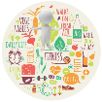
Pupils will understand what it means to be healthy, both physically and mentally. They will discover who can support them with keeping safe and healthy in our school, the community and the wider world. Pupils will learn what their body needs to keep them healthy and how this includes their mental health and well-being. They will understand that lifestyle choices such as friendship groups can have a negative impact on their health.

Relationships
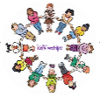
Pupils will develop an understanding of healthy relationships, including managing peer pressure and control in different relatiionships. They will gain strategies for recognising and managing their feelings as well as developing relationships with friends and family, including conflict resolution and communication skills. They will also learn about bereavement and loss.

Changing me
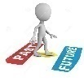
Pupils will learn how their bodies change and develop as they get older, including the differences between boys and girls. They will learn about puberty, conception, pregnancy and birth.

Knowledge and skills sequencing |  |  |  | PSHE
 | EYFS | Y1 | Y2 |  | Y3 | Y4 |  | Y5 |  | Y6
Being me in my world | To understand that there are similarities and differences between me and my friends.  To show that I understand my own feelings and feelings of others.  To manage my own feelings.  To explain why we have rules and know the difference between right and wrong. | To explain why my class is a happy and safe place to learn.  To give different examples where I or others make my class happy and safe. | To explain why my behaviour can impact on other people in my class.  To compare my own and my friends’ choices and can express why some choices are better than others. |  | To explain how my behaviour can affect how others feel and behave.  To explain why it is important to have rules and how that helps me and others in my class learn. To explain why it is important to feel valued. | To explain why being listened to and listening to others is important in my school community.  To explain why being democratic is important and can help me and others feel valued. |  | To compare my life with other people in my country and explain why we have rules, rights and responsibilities to try and make the school and the wider community a fair place.  To explain how the actions of one person can affect another and can give examples of this from school and a wider community context. |  | To explain how my choices can have an impact on people in my immediate community and globally.  To empathise with others in my community and globally and explain how this can influence the choices I make.
Celebrating difference | To show sensitivity to my own needs and the needs of others.  I know how to be a kind friend.  To stand up for myself and know what words to use if someone is being unkind.  To understand that being different is what makes me special and that it is okay if we are all good at different things. | To tell you some ways that I am different and similar to other people in my class, and why this makes us all special | To explain that sometimes people get bullied because they are seen to be different; this might include people who do not conform to gender stereotypes. |  | To describe different conflicts that might happen in family or friendship groups and the effects of what people say in these situations | To tell you a time when my first impression of someone changed as I got to know them. To also explain why bullying might be difficult to spot and what to do about it if I’m not sure. |  | To explain the differences between direct and indirect types of bullying and can offer a range of strategies to help myself and others if we become involved (directly or indirectly) in a bullying situation. |  | To explain ways in which difference can be a source of conflict or a cause for celebration.

 | EYFS | Y1 | Y2 | Y3 | Y4 | Y5 | Y6
Dreams and goals | To talk about jobs I might like to do when I am older.  To work towards a simple goal.  To try new activities and show independence, resilience and perseverance when something is difficult. | To explain how I feel when I am successful and how this can be celebrated positively. | To explain how I played my part in a group and the parts other people played to create an end product. To explain how our skills complemented each other. | To explain the different ways that help me learn and what I need to do to improve. | To plan and set new goals even after a disappointment. | To compare my hopes and dreams with those of young people from different cultures. | To explain different ways to work with others to help make the world a better place
Healthy me | To manage my own basic hygiene and personal needs, including dressing, going to the toilet and personal safety.  I understand why it is important to make healthy food choices and exercise. | To explain why I think my body is amazing and can identify a range of ways to keep it safe and healthy. | To explain why foods and medicines can be good for my body comparing my ideas with less healthy/ unsafe choices | To identify things, people and places that I need to keep safe from, and can tell you some strategies for keeping myself safe and healthy including who to go to for help. | To recognise when people are putting me under pressure and can explain ways to resist this when I want to. | To explain different roles that food and substances can play in people’s lives. To also explain how people can develop eating problems (disorders) relating to body image pressures and how smoking and alcohol misuse is unhealthy. | To explain when substances including alcohol are being used anti-socially or being misused and the impact this can have on an individual and others.
Relationships | To be able to form positive attachments to adults and have friendships with peers;  To have some strategies to use if you feel upset or angry  To be able to work and play cooperatively, take turns with others and think of ways to mend friendships | To be able to explain why you have special relationships with some people and how these relationships help you feel safe and good about yourself.  To be able to also explain how your qualities help these relationships | To be able to explain why some things might make people feel uncomfortable in a relationship and compare this with relationships that make people feel safe and special. | To be able to explain how your life is influenced positively by people you know and also by people from other countries. | To be able to recognise how people are feeling when they miss a special person or animal. | To be able to compare different types of friendships and the feelings associated with them.  To be able to also explain how to stay safe when using technology to communicate with your friends, including how to stand up for yourself, negotiate and to resist peer pressure. | To be able to identify when people may be experiencing feelings associated with loss and also recognise when people are trying to gain power or control.

 | EYFS | Y1 | Y2 | Y3 | Y4 | Y5 | Y6
Healthy me | To understand that we all grow from babies to adults  To be able to name parts of the body | To be able to compare how you are now to when you were a baby and explain some of the changes that will happen to me as you get older.  To be able to use the correct names for private parts of the body and give reasons why they are private. | To be able to use the correct terms to describe private parts of the body and explain why they are private.  To be able to explain why some types of touches feel OK and others don’t. | To be able to explain how boys’ and girls’ bodies change on the inside/outside during the growing up process and can explain why these changes are necessary so that your bodies can make babies when you grow up. | To be able to summarise the changes that happen to boys’ and girls’ bodies that prepare them for making a baby when they are older. | To be able to explain how boys and girls change during puberty and why looking after yourself physically and emotionally is important.  To be able to also summarise the process of conception. | To be able to describe how a baby develops from conception through the nine months of pregnancy, and how it is born.

