PAISLEY PRIMARY SCHOOL

We value every child in our community: we want them to aspire to the greatest things!

BEHAVIOUR POLICY

September 2023

Introduction
At Paisley Primary School we have high expectations of behaviour. We encourage all children to behave well, to demonstrate respect and to take responsibility for their own actions. We believe that high expectations of behaviour ensure high standards of teaching and learning are achieved, on a daily basis in our school. This policy is written in line with the school’s Child Protection/ Safeguarding, e-Safety, Health & Safety, SEND, (Special Educational Needs & Disability), Equal Opportunity, Educational Visits and Whistleblowers Policies, together with the school’s Accessibility and Equality Plans.

At Paisley, our behaviour policy is centred around our vision and six golden rules:

We value every child in our community: we want them to aspire to the greatest things!

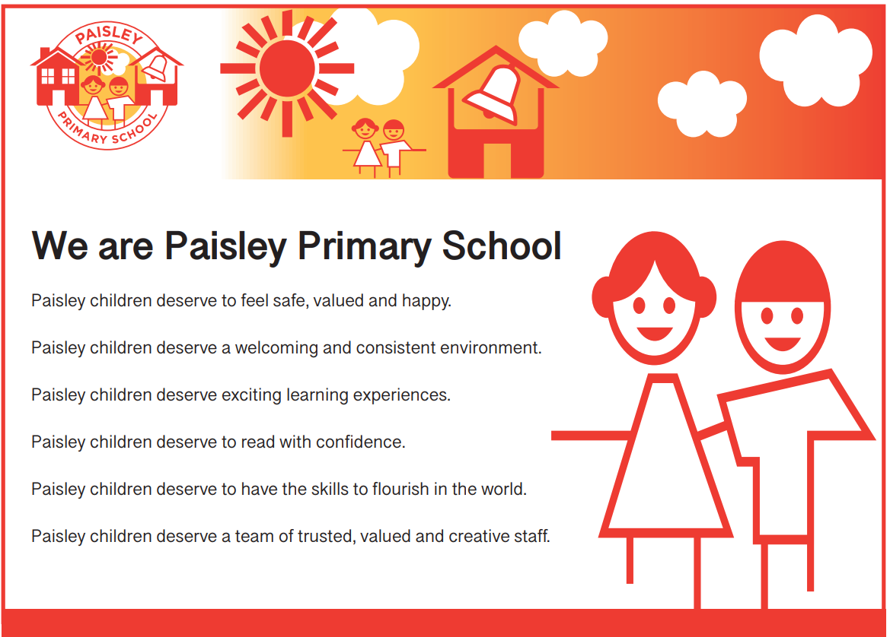

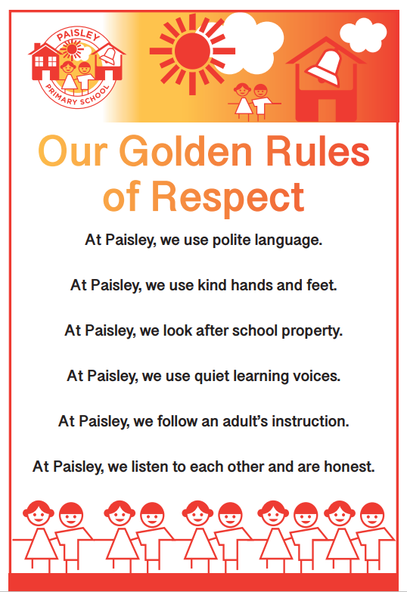
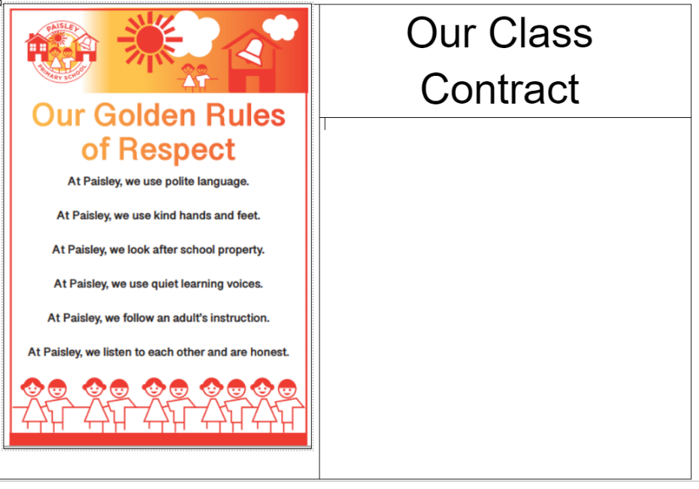
All children sign a class behaviour contract at the start of the academic year to agree to follow our six golden rules in all areas of our school community. When children do not follow our six golden rules, teachers use the behaviour traffic light to manage and/or sanction these behaviours – this is done on an individual basis and professional judgement should always be exercised.

Our aims for behaviour are:
- Paisley Primary School will be a safe place for all pupils to enjoy their learning;
- Every member of the school community will be treated with respect;
- Children will show understanding of themselves and others, enabling them to become excellent citizens of our school community and the wider community;
- A supportive and trauma-informed system is in place, where children learn from their mistakes, make improvements and follow the example of others;
- Children develop self-confidence and self-esteem;
- We appraise and highlight excellent behaviour choices;
- Everyone is able to learn in a calm, purposeful and positive environment;
- Inappropriate and/or unacceptable behaviour is promptly addressed;
- Personalised behaviour plans and provision are in place for pupils who need additional support with their behaviour
- We communicate with parents, external agencies and the wider community to improve behaviour and ensure high standards are met;
- We promote a culture of high reward, praise and celebration every day;
- Our house system ensures all children have equal opportunities to earn rewards
- We select a positive parent phone call every week – a member of staff telephones the parents/carers of a child from every classroom who has shown excellent behaviour and/or had a great week; we always positively appraise and love to share this with our families!

SEND, Equal Opportunities and Inclusion
It is our responsibility to ensure this policy is equally accessible for all, regardless of gender, ethnic origin, physical or intellectual ability. Support is provided for children with behavioural needs. Targets towards addressing individual behavioural needs are set through a personalised behaviour plan, with Ms. Lee, SENDCo, in conjunction with Mrs Juggins, Deputy Headteacher, the child’s class teacher, parents and the child. The personalised behaviour plan sets appropriate, measurable targets for the individual child alongside a programme of in-school provision, in conjunction with potential external agency involvement, the parents/carers and the child. The PSP will be reviewed on a regular basis.

Responsibility
This policy is the responsibility of all staff. It is the responsibility of all staff to model appropriate behaviour and to ensure the safety and well-being of all children and staff in school. All staff should have high expectations of behaviour in order for good teaching and learning to take place. The Local Advisory Board has a duty to ensure that the school has effective policies and procedures in place.

Training & CPD, (Continuing Professional Development)
All staff and stakeholders will receive training on the school’s Behaviour Policy. Further training, as a result of any moderations or reviews of practice and procedure, will be provided, as necessary, and will form part of the school’s INSET timetable and Development Plan. New staff and volunteers will receive a copy of the policy and procedures and will discuss its content with the Head of School or a member of the senior leadership team, as part of the school’s induction process. Any CPD or training needs will be identified and addressed as a result of appraisal interviews, reviews and targets. Training for individuals, groups or whole-school staff may also be accessed from the Trust, local authority or other external providers, should a need by identified.

Rewarding and Celebrating Behaviour
At Paisley, we reward good or better behaviour every day through our culture of high reward and praise. The house teams community system is integral to this culture – children earn house points for their team from all members of staff and in all areas of the school community. These points are totalled and the winning team achieves a half termly reward, as a team. Each classroom has a positive behaviour ladder (shown overleaf) – on this display, children are highlighted for making excellent choices in school. Further to this, each week, improved attendance is rewarded, in addition to half termly and termly prizes. Below are the identified methods of reward at Paisley Primary School:
- House points
- Platinum Points
- Weekly Gold Book Celebration Assembly
- Wow notes
- Great day notes
- Weekly/termly attendance winners – house points
- Weekly WOW assemblies
- Personalised rewards for pupils with a personalised behaviour plan
- Weekly positive parent phone call home

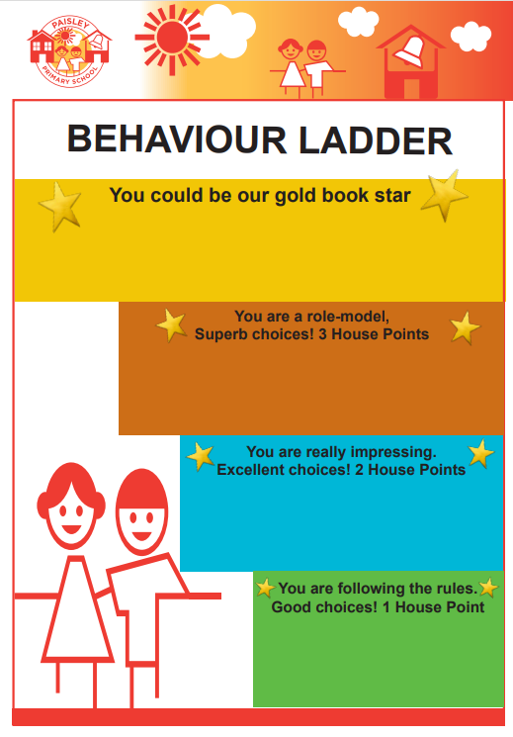
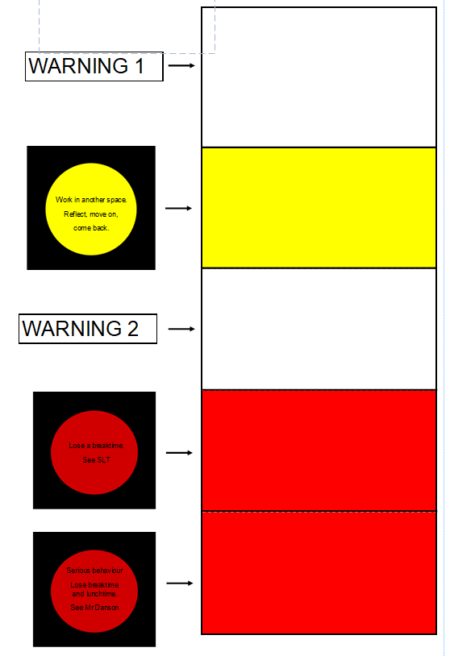

Daily procedure for managing behaviours
- Each new day is a fresh start
- Teachers use the behaviour ladder to appraise good (or better) behaviour choices and award the corresponding house points as a reward to the child and to encourage others. Teachers write the names or initials of the child on the correct step of the ladder.
- If a child is not showing at least a green standard of behaviour or following the golden rules, the teacher should issue a warning and explain clearly what the child needs to do to improve their behaviour (see the warning chart above). Explain clearly that the consequence will be to move to amber if behaviour does not improve. Please note – this warning chart is not to be displayed in the classroom, but it is a point of reference on the teacher’s desk.
- If the child continues to show poor behaviour, the teacher should move the child to amber and give clear instructions to the child about how they can get themselves onto the behaviour ladder for excellent, or improved, choices. At the amber stage, a child should go and work in another supervised space (or partner class) in school, reflect and move on (for no more than 15 minutes).
- When the child shows better choices, the teacher can appraise this immediately on the behaviour ladder.
- Should the child continue to show poor behaviour, the teacher should issue a further warning and make it clear that there will be consequences should they move to red.
- Moving a child to red is the final step of our class behaviour management system. The child will still be given chance to modify their behaviour at this point and the teacher should communicate with them privately ensuring that they understand the situation and to remind them of the consequences and if appropriate, how they have succeeded at getting back onto the behaviour ladder in the past. A child will miss a breaktime for moving to red.
- If poor behaviour continues, the teacher can give them time away from the class or direct them to a member of SLT, who will inform parents, where necessary.
- When the child returns to the classroom, they will be given a ‘fresh start’ and the chance to earn their place on the behaviour ladder.

Serious red behaviour incident
- If a child shows any behaviours that are shown below, they should be moved to the second red box and sent to a partner class, or an SLT colleague, for reflection time (at the teacher’s discretion). After 10-15 minutes, or longer if necessary, the child should return to class and be given the opportunity to turn their behaviour round and earn a place on the behaviour ladder.
For incidents of physical contact, fighting, foul language or if a child repeatedly ignores adult instruction, then 1x morning playtime and 1x lunch playtime are lost and spent indoors with SLT.

Examples of behaviours may include;
- Lack of respect for people or property – both physical and/or verbal
- Rudeness
- Foul and abusive language or gestures
- Continued refusal to tell the truth
- Physical contact
- Behaviour that puts themselves or others at risk of harm
- A violent act towards another person
- Threatening behaviour towards others
- Racial, homophobic or prejudicial abuse
- Persistent refusal to follow instructions
- Theft
- Spitting
- Running away from an adult
- Deliberate damage to property in school
- Bullying (see anti-bullying policy)
- Not following one of the six golden rules.

Please note that this list is not exhaustive and contains examples of behaviours. Teaching staff should always exercise their professional judgement and a personalised approach towards supporting children to behaviour well.

Communicating and Working with Parents and Carers
The partnership with parents/carers is essential in order for children’s inappropriate behaviour to be addressed and for improvements to be made. At Paisley Primary School we are pro-active in contacting parents to offer support for parents of child where behaviour may be causing a concern. We also work closely with a variety of external agencies, where appropriate, to offer families additional support. The Head of School, Deputy Headteachers and Designated Safeguarding Leader, Mrs. Hoy, are always available for parents to contact for support, in addition to Ms Lee, SENDCO. Where meetings/conversations take place with families, minutes / notes will be documented on CPOMs for future reference.
Communication Procedure
- Any child who gets to red should have their parents/guardians spoken to by the class teacher in the first instance and it should be recorded on CPOMs.
- A child who repeatedly reaches red over a week should have a meeting arranged by Ms Lee, and/or Mrs Juggins together with the teacher to discuss the consequences for continued poor behaviour and establish a plan or provision to address the needs or concerns. All stakeholders including the class teacher should sign the plan and work towards its completion.
- If a child loses X3 break and lunchtimes over a short period of time for physical contact, fighting, foul language or if a child repeatedly ignores adult instruction, then a meeting with parents/carers will be arranged to discuss the matter.

If a parent/carer does not respond to requests, in writing, to attend a meeting, the Head of School will telephone the parent/carer directly to arrange a meeting.

Suspension
In exceptional circumstances, fixed term suspensions or exclusions may be enacted. Please see the suspensions and exclusions policy for further details.

Playtimes
Our behaviour policy and six golden rules will continue at playtimes with pupils having warnings/movement on the teacher traffic light record, where needed. If a child shows poor behaviour, such as breaking the golden rules, then they go inside to the member of SLT who is supervising indoor lunch duty.

Lunchtimes
Lunch time staff report incidents to teaching staff, where necessary. It is the responsibility of the SLT member to log any children who have been sent in for indoor lunch, due to poor behaviour. Teaching staff will be ready for 12.55pm and will greet the children in their lines at the end of the lunchtime period. If unavailable, a TA should meet the class.

Educational Visits and Sporting Events
In line with our Educational Visits policy, parents of any child displaying inappropriate behaviour will be contacted when a letter goes out notifying parents of a forthcoming trip. If behaviour is causing concern, the class teacher (with Mrs Juggins or Ms Lee) will meet with the parents and the child’s behaviour will be monitored in the period before the visit. Every effort will be made for a child to be included on the visit, including asking parents/carers to accompany the child. Alternatively, other strategies may be employed, i.e., assigning 1:1 support for the child. If the child’s behaviour could pose a health and safety risk to others and themselves, they will remain in school while the visit takes place and will continue with learning associated with the visit. If a child has displayed inappropriate behaviour on a previous visit when representing Paisley Primary School, the school reserves the right to exclude the child from subsequent visits and the parents would be informed.

Behaviour in relation to attendance at Extra-curricular Clubs
If a child’s behaviour has been a cause for concern throughout the school day and the child is due to attend an after-school club, the school reserves the right to withdraw the child from the club and the parents will be contacted and informed as soon as possible. If the school has been unable to contact the parents, the child will be supervised by the Head of School or a member of the senior leadership team until the parents arrive. If a financial reimbursement needs to be made, the school office will arrange payment for the following day.

Behaviour beyond the school day
We recognise that when in the community, our children are ambassadors of Paisley Primary School. Therefore, in conjunction with parents/families, we will challenge inappropriate or unsafe behaviour in our locality in school and liaise with external agencies to support pupil’s behaviour. We want our children to aspire to the greatest things in all areas of their lives and this includes behaviour within the wider community. The health, safety and well-being of our pupils are of paramount importance to all adults who work in our school. Staff at Paisley Primary School recognise that protecting children and young people is a shared responsibility and depends upon the effective joint working between agencies and professionals that have different roles and expertise. Our children have the right to protection, regardless of age, gender, race, culture or disability - they have a right to be safe in our school and in the community.

Upon request, Paisley Primary School will support parents/carers with strategies to improve a child’s behaviour in the home.

Peer-On-Peer Allegations

Staff must recognise that children are capable of abusing their peers. Reporting systems in place are well promoted, easily understood and easily accessible and have the confidence of children and young people. Even if there are no reported cases of peer-on-peer abuse, such abuse may still be taking place and is simply not being reported. There is a zero-tolerance approach to abuse. Abuse between pupils will never be tolerated as this can lead to a culture of unacceptable behaviours and an unsafe environment for children. Cases of pupils hurting other pupils will be dealt with promptly under this policy, alongside the consultation with the school’s Child Protection and Safeguarding Policy and Keeping Children Safe in Education.
Child on child sexual violence or sexual harassment can happen in or outside of the setting, as well as online, we follow the “it could happen here” approach. All reports are taken seriously and all parties are supported throughout. As a school, we take a reflective approach, regularly reviewing decisions and actions and updating the relevant policies to reflect learning.

The school will minimise the risk of peer-on-peer abuse by:

  - Challenging any form of derogatory or sexualised language or behaviour
  - Being vigilant to issues that particularly affect different genders – for example, sexualised or aggressive touching or grabbing towards female students, and initiation or hazing type violence with respect to boys
  - Ensuring the curriculum helps to educate students about appropriate behaviour via our PSHE programme – Jigsaw
  - Ensuring that pupils are aware of their duty to report peer-on-peer abuse to the Safeguarding Team or other member of school staff to ensure all pupils are safe within the school
  - Ensuring pupils know they can talk to staff confidentially by visiting the Safeguarding Team in person or seeking the support of any member of staff.
  - Ensuring staff are trained to understand that a pupil harming a peer could be a sign that the child is being abused themselves, and that this would fall under the scope of this policy

Prevention of Extremism and radicalisation
Paisley Primary School is committed to the prevention of Extremism and Radicalisation. The school adheres to DfE and LA guidance and advice; monitoring, evaluation and review practice, as necessary.
The safeguarding Officer, Staff and Governing Body receive LA training and any associated updates.

Monitoring, Evaluation and Review
This policy will be reviewed on an annual basis. This policy will be reviewed September 2023 or earlier, in response to needs identified as a result of monitoring, evaluating and review.

Mr Danson Ms. Josie Speck
Head of School Chair of Governors

September 2023
Review date: September 2024

APPENDIX A

Responding to negative behaviour

When giving reminders….

*child persistently causing low levels of disruption*
At Paisley we follow our six golden rules. Please can you put down the pencil and listen carefully. Thank you.”

*child name calling*
At Paisley, we use polite language, thankyou for using kind words when speaking to people.

*child swinging on a chair or playing in an unsafe way outside*
At Paisley we need to keep ourselves safe. You need to keep your chair on the ground. Thank you for following an adult’s instruction.

When giving warnings….

After a reminder, if the behaviour persists then move child onto amber and tell them how to turn things round and earn a place on the behaviour ladder
“To get onto green, or better, you need to _________”

If children aren’t co-operating:
I can see you’re not ready to talk at the moment. I will come back in __ minutes.

APPENDIX B

Guidance for staff

Paisley House Teams
The Astonishers - The Extraordinaires The Incredibles - The Unstoppables
- Every child has been placed in one of the four house teams above.
- Every member of staff has been placed in one of the four house teams above.
- Families are all in the same house team
- In every classroom, there are four ‘pots’ – one for each house team.
- Children earn house points (green tokens) and add these to their pot. All staff can give house points to any child. (No more than three at a time, unless if it is something exceptional!)
- House points can be earnt by anyone for fantastic choices. In particular, for following the 6 Golden Rules. In the classroom, on the playground, on the corridor, in the hall etc.
- In the classroom, if a child’s name is written on the positive behaviour ladder, the corresponding house points are earnt (1, 2, 3) and green tokens added to the pots.
- If a child is in Gold Book on Friday, they earn 4 house points for their team.
- At the end of every day, each house team’s total will be collected and recorded and the pots emptied of green tokens to start a new day.
- On a weekly basis, Y6 house captains will collect totals from every classroom.
- In Gold Book, the winning house team will be announced – later they will come to the hall and then have a ten minute afternoon playtime at 2pm on a Friday as a reward.
- In Gold Book, the house team with the best attendance for the week will win 10 additional house points for their team.
- In classrooms, the winning house team with best attendance for the week will win an extra 3 house points for their team.
- Every child with 100% attendance for the week achieves one house point.
- Individual children with a behaviour plan / attendance plan etc may earn house points for achieving specific daily targets and tasks
- Children earn 1 house point for achieving their weekly three reads target
- Every half term, the winning house team will have a bouncy castle morning or agreed prize/activity.
- Every half term, we will have a house team community afternoon, where children will take part in team building community activities with their peers from across the school.
The aim of house points is to create a culture of aspiration and high reward at Paisley. House points give us the chance to fill our school with positivity, by appraising excellent choices and celebrating pupils who demonstrate high standards of learning behaviour.
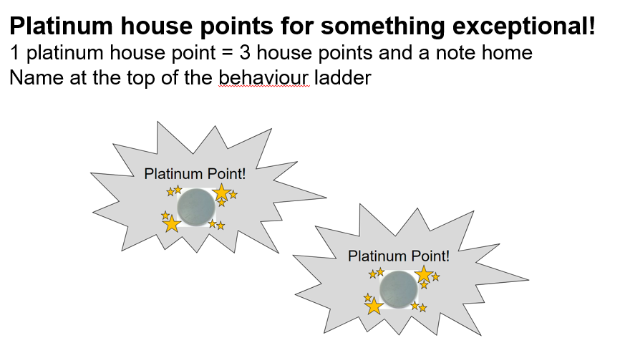

APPENDIX C

Guidance for teachers – our Paisley Principles for Behaviour – what we do, everyday, in school!
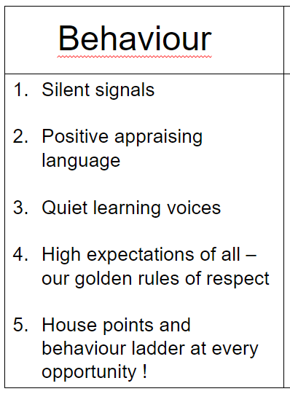

APPENDIX D

Appraising good behaviour first

