PAISLEY PRIMARY SCHOOL

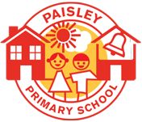

We value every child in our community: we want them to aspire to the greatest things!

School Prospectus
2023-24
Paisley Primary School
Paisley Street
Kingston upon Hull
HU3 6NJ
Tel: 01482 355984
Fax: 01482 571299

Email: admin@paisley.hull.sch.uk
Websites: paisleyprimaryschool.org.uk

Welcome to Paisley Primary School. At our school, we value every child in our community: we want them to aspire to the greatest things! Our school is part of the Constellation Trust Multi-Academy Trust. We are proud of our diverse learning community; children join us from all walks of life and from all over the world and we love to celebrate this! Through our curriculum offer, we aim for all of our children to grow as happy, successful and respectful citizens of our community.

Our carefully planned curriculum is designed to ensure that learning is precisely matched to the needs of our children and our community. Our curriculum drivers are reading, vocabulary, community, aspiration and inclusion. Everything we do in school is centred on these drivers, from the stories we read, to the assemblies we deliver, to the design of our learning environment. We place the utmost important on ensuring that our children are happy, safe and valued during their time with us.

Community is crucial to us all here at Paisley Primary School! We value your contributions as families of our children and always encourage you to come in and see us, or catch us on the gate at the begnnings and ends of the day. Through working in partnership with our parents and carers, we can have the highest expectations for all children to reach their full potential and aspire to the greatest things.

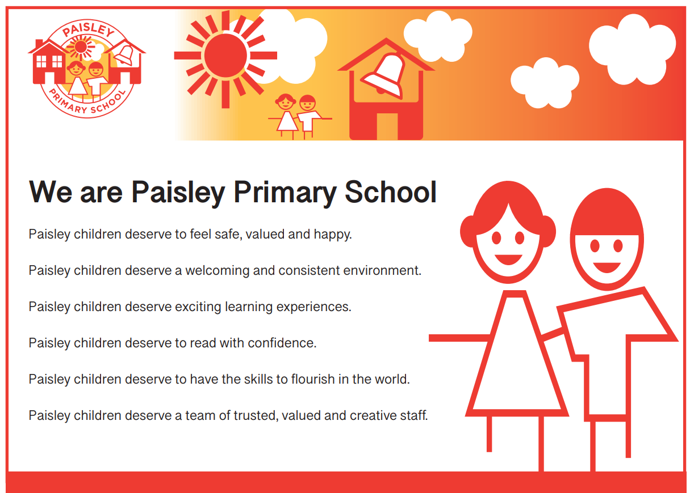

You will find further information about our school on this website. The best thing to do is to come in and see us – we operate a fully open door policy at Paisley and would love to welcome you into our community!

Mr Danson
Head of School

CONTENTS

- The Paisley Team

- Our School Day

- Our School Aims

- Our School Uniform

- Our Behaviour Code

- Curriculum Information

- Other Curriculum Information

- General Information

- Assessment Information, 2022

- The Paisley Team

Mr Danson Head of School
Mrs Juggins Deputy Headteacher/DDSL/trust maths lead
Mr Luscombe Deputy Headteacher/KS2 leader

Mrs Hayward Assistant Headteacher/EYFS Leader
Ms Lee SENDCO

Mrs Inchbold KS2 teacher/curriculum team leader
Mrs Moss KS1 leader and Phonics leader
Mr McDougall KS2 teacher
Mrs Haseldine KS2 teacher
Miss Tether KS2 teacher
Miss Hart KS2 teacher
Mr. Hulland KS2 teacher
Mrs Samuel PPA teacher
Miss Griffin KS1 teacher
Mrs Allgood KS1 teacher
Mrs Thomas KS1 teacher

Mrs Spaven Foundation Stage teacher
Mrs Bursell Foundation Stage teacher
Mrs. Hoy Child Protection Officer & Designated Safeguarding Lead
Mrs. Stokes Office Manager
Mrs Mould Administrative Officer
Mrs Maundrill Administrative Officer & Principal First Aider
Mr Corlass Site Facilities Officer
Mrs Thomas PPA cover
Mrs Murarova EAL interventions

Local Advisory Board
Mr Danson Head of School
Ms Speck Chair of LAB
Mrs Beetham Parent Governor
Mr Rhodes Trust governor

Teaching Assistants
Mrs. Parker, Mrs. Dance, Mrs. Wilson, Mrs. Mitchell, Miss Morris, Mrs. Sleight, Mrs. Sharp, Mrs. Tallett, Mrs. Jennings, Mrs. Atkinson, Mrs. Lowther, Mr. Perkins, Miss Jones, Mrs Rudderforth

Lunchtime Supervisors
Mrs. Morgan, Mrs. Crompton, Mrs. Brewin, Miss Morris, Miss Jones, Miss Morris, Mrs Lowther, Miss Mussared

2. Our School Day

Foundation Stage 1 Hours (children entitled to 15 hours)

Morning session 8:50am – 11:50 noon

Afternoon session 12:00 noon – 3:15pm

Foundation Stage 2 Hours (children in full-time education)
Morning session 8.45am* – 11.30am
Afternoon session 12.30pm – 3.15pm

Key Stage 1 and 2 (Y1 – Y6 - children in full-time education)
Morning session 8.45am* – 12:00am
Afternoon session 1:00pm – 3.15pm

* Full time children should be on site and ready to enter the building by 8:40am. Key Stage 1 and Key Stage 2 external doors close at 8:55am.

Responsibility for Children on site before the start of the school day
Children should be accompanied onto the school site. It is the responsibility of the parent/carer to oversee the child before the start of the school day. If a child comes to school independently, and their behaviour, prior to the start of the school day is a cause for concern, the parent/care will be contacted by the Head of School or a member of the senior leadership team and will be encouraged to consider using the school’s Breakfast Club facility and/or will be asked to accompany the child to school.

Collective Worship
Monday – whole school assembly – Golden Rules
Tuesday – class reading assembly
Wednesday – phase assembly – British Values
Thursday – class WOW assembly
Friday – whole school gold book assembly

Play Time School Lunch Time
10:45am – 11am 12:00noon – 12:55pm

Visiting Arrangements
Appointments to visit during school sessions may be made either by personal contact, email, telephone or letter direct to the school. There are Open Classroom Events, Assemblies and Parent Consultation Evenings for our families during the year to provide the opportunity for discussion about individual children’s progress and to celebrate learning. Parents/carers are encouraged to contact the school whenever they need to. They can speak to a senior member of staff on the gate or book an appointment through the school office.

Number on Roll, (as of July 2023)
327 full-time, (33 part-time nursery children)

School Classification

Academy

Admissions Policy
The school’s current admission arrangements adhere to the Hull City Council’s admission guidelines and policy.

Breakfast Club
Breakfast Club is available to all children from 8:00am every morning. Admittance is from 8:00am. A balanced breakfast of cereal and toast is available and the children are supervised by our Breakfast Club team until they are taken to their classes for the start of the school day. Further details are available via the school office. The cost of our Breakfast Club is £1, payable through the online payment service (full details available at the school office).

Snacks
The Local Authority provides a daily portion of fruit for children in the Foundation Stage and in Key Stage 1. Children in Key Stage 2 may bring a portion of fruit as a snack on a daily basis. All children have access to chilled, filtered water throughout the day - children are to bring their own water bottle which can be filled at school and these are to be taken home daily to be washed ready for the next school day.

Lunchtime

A full school meal will be available for all school aged children. School meals are free for foundation and key stage 1 children, £1.50 for year 3 onwards. Meals are prepared and cooked on the premises by our cook and her catering team and children are supervised by a team of Lunch Time Supervisors. All our meals are well balanced and nutritious. We encourage all our children to eat well! Children are able to bring a packed lunch to eat on the premises but we do ask that you provide food that is healthy and balanced. We do not allow sweets or chocolates at lunchtime. If your child is entitled to a free school meal, make sure you apply, even if they currently wish to stay packed lunch. Free school meal data is important to our school. As a result of children in receipt of free school meals, the school receives government funding in the form of Pupil Premium money to support teaching and learning. Details of pupil premium expenditure are available on the school website. Further details on free school meals entitlement are available from the school office.

3. Our vision
Paisley Primary School

We value every child in our community: we want them to aspire to the greatest things!

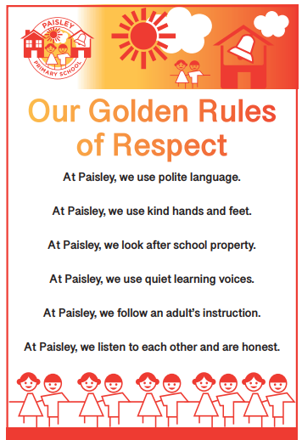

4. Our School Uniform

Our Local Governing Body has approved a school uniform for the children attending Paisley Primary School. We feel it helps the children to feel part of our school community and creates pride in appearance.

Winter Uniform
- Black or Grey trousers, skirt or pinafore
- White shirt, blouse or polo shirt
- Red sweatshirt, cardigan or jumper
- Red bookbag

Summer Uniform
- Red and white check dress or skirt
- White shirt, blouse or polo shirt
- Grey school shorts
- Red bookbag

We do not insist that the uniform contains a logo. It is at the discretion of the parent. Uniforms containing our logo are available from the school office or can be ordered online via www.gooddies.co.uk and by clicking on the clothing and embroidery service options. If you have any enquiries about school uniform, please contact the school office, who will be pleased to help. We aim to recycle school uniform, via unclaimed lost property, wherever possible.

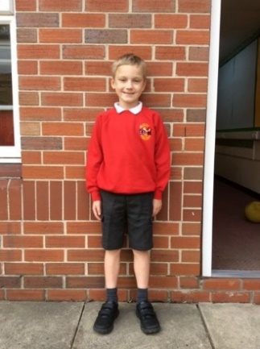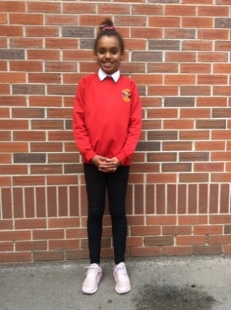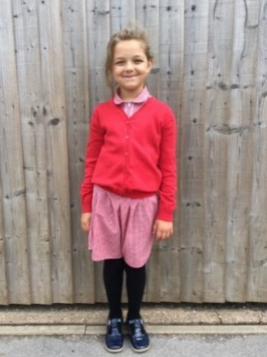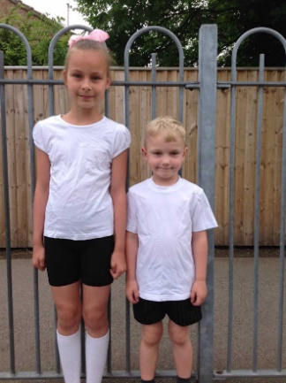

PE Kit
Children will need a plain, white T shirt and navy or black shorts and suitable outdoor shoes. A tracksuit top with long sleeves and leggings are also permissable for outdoor PE sessions during cooler weather. Unless outdoors, children will do PE bare foot, as this improves the grip needed on apparatus, causing fewer accidents. Suitable footwear should be worn for outdoor PE sessions and sports days. If a child does not bring PE kit, school PE kit will be provided in order to take part in the lesson. PE kits are to be brought into school at the start of each term. They will be returned at the end of each term to be washed/changed as necessary. The children will all receive a red PE bag to keep their belongings safe in the cloakrooms.

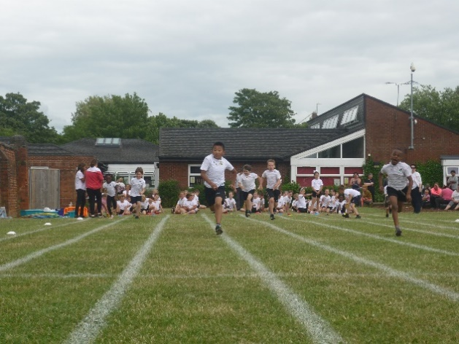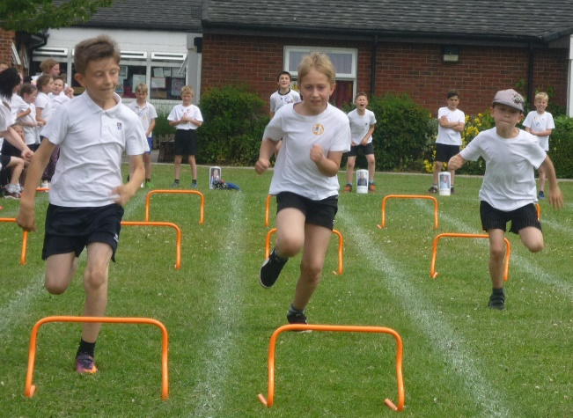

Jewellery
For health and safety reasons the only items of jewellery permitted are stud earrings and a sensible watch. All other items must be removed before school. For PE, stud earrings must be removed. The child must be able to do this independently. If you are considering having your child’s ears pierced, please try to do this at the start of the summer holiday, as this would allow sufficient healing time before the start of the autumn term.

Lost Property
Please write your child’s name on all items of clothing brought to school. This won’t stop it getting lost but it will, hopefully, find its way back quicker! Occasionally, items do get accidentally lost or misplaced. The school accepts no liability for lost, misplaced or damaged items. Children should not bring their own play equipment or personal effects to school. We have plenty of play equipment for playtimes and lunchtimes.

Mobile Phones
We do not allow mobile phones during school hours. If a Y5 or Y6 child comes to school with a mobile phone for emergency use, (i.e. walking home unaccompanied from school), the phone and any associated hardware, (i.e. headphones), must be placed in one of the clear bags with a senior member of staff on gate duty, or brought directly to the school office at the start of every day and collected at 3:15pm. The school accepts no responsibility for any lost, misplaced or damaged mobile phones and associated hardware.

5. Our Behaviour Policy
Excellent behaviour is given the highest priority in our school. We have clear behaviour policy which is based on our six golden rules. All staff receive regular training on managing behaviour and supporting children to achieve the highest expectations. Our behaviour policy, together with our Paisley Principles, ensure that our school is a calm, purposeful and positive learning environment. Through our house teams system (The Incredibles, The Unstoppables, The Astonishers and The Extraordinaires), we ensure a culture of high reward at Paisley – we want all of our pupils to aspire to the greatest things!

We believe that excellent behaviour is best achieved through self respect and respect for others – our six golden rules ensure that these values are placed at the forefront of our curriculum offer. Everyone is valued, respected and celebrated. We promote, encourage and reward children who are excellent members of community. Our behaviour policy ensures that all children feel safe, happy and valued at all times in our school.
Paisley Primary School operates a behaviour ladder system. We reward and praise good or better behaviour through the behaviour ladder and in many other ways:
- House point winners and the associated weekly, half termly and termly rewards
- Wow moments, great day notes and platinum points
- Gold Book Friday assembly
- Reading tree winners and associated house points
- Attendance rewards and associated house points
- Personalised rewards for pupils with a behaviour plan
- Weekly Wow Work assembly (in classes)
On occasions of inappropriate behaviour, we deal with this quickly, firmly and fairly. Parents are informed at an early stage and we actively encourage your support and engagement in dealing with behavioural issues. Some pupils have a personalised behaviour plan to support them to meet our high expectations in school and to make excellent choices. Such plans are agreed with a child’s family, teacher and the child themselves.

Further information on our Behaviour Policy and procedures are available from the school office or our website.

Anti-Bullying
We consider bullying to be a very serious matter and deal with it promptly whenever it arises. We have a policy for dealing with any allegations of bullying and we make sure that our response is appropriate, swift and consistent.

Racism, homophobia and discrimination
Racism will not be tolerated at Paisley Primary School. Any racist incidents/language or homophobic language will be logged and dealt with promptly, should they arise. All incidents are reported to the Local Authority.

Conduct on the school site
Please note that the school will not tolerate verbal or physical aggression on site from parents/other adults. Should such a situation arise, the Head of School may enforce an off-site ban for a fixed period of time. No dogs, apart from guide dogs, should be brought on site and there are notices to this effect around the school. The school also has CCTV around the site and CCTV/audio recording in the school entrance. Our Child Protection/Safeguarding and e-Safety policies are available on the school website and hard copies are available to view from the school office, on request.

6. National Curriculum Information

Class Organisation
In delivering the school curriculum, Reading, Writing and Mathematics are taught as discrete subjects in the mornings. Foundation subjects are taught in an afternoon. Classes in school are a combination of discrete year group and mixed year group classes.

Curriculum

The foundations of our curriculum offer are our five curriculum drivers:

Reading | Vocabulary | Community | Aspiration | Inclusion

These golden threads underpin our entire curriculum at Paisley Primary School.
We believe these drivers are exactly what our children need to make good progress academically, personally and socially. We want Paisley children to be excellent citizens of our community in the city of Hull. We believe that our golden threads will ensure that all our children aspire to the greatest things and are really successful in their learning, across the curriculum.
Reading
We want all Paisley pupils to foster fully positive attitudes towards reading. Our curriculum prepares pupils to read fluently and with confidence. In EYFS and Key Stage 1, the primary focus for our pupils is to develop accuracy and speed in decoding sounds and words. As they move through school, our children read and discuss a range of progressively more complex texts. Our Paisley Reading Spine contains high-quality literature with a wide range of language and structures for our pupils to explore. These texts, stories and books ensure that our pupils are excited about reading and prepared for Key Stage Three and beyond. Our reading spine is aspirational – our pupils are enthused by new books and have the prior knowledge and fluency to ensure that they comprehend and really enjoy them. In every classroom, every child is read to everyday; storytime is an essential aspect of the school day at Paisley. Our children love the experience of being read to, everyday! In story time, our pupils deepen their understanding of our three drivers: community, aspiration and inclusion through the books chosen. Excellent stories encourage our children to think deeply, to reflect and consider others. Our children have the opportunity to read across all subjects to acquire knowledge, carry out research and unlock learning across the curriculum. Through being confident readers, our children learn to love reading, they love talking about the books that they have read and feel proud to share their reading achievements with others.
At Paisley, our children learn to read, they read to learn and they love to read.
Vocabulary
At Paisley, reading and vocabulary development go hand in hand. Our children develop speedy word reading skills and good language comprehension. We give children the tools and the language to communicate effectively in spoken and written forms. Our children learn to use and understand language that they can apply across the curriculum, giving them the confidence to speak clearly and articulately. Staff model and explicitly teach vocabulary, with language being an integral teaching point of all learning sequences. Vocabulary is a planned essential component of all curriculum documentation across all subjects. Taught vocabulary is specified so that all children develop a deep understanding of curriculum areas and can use high-level vocabulary to communicate their learning with clarity. We ensure that every area of the curriculum prepares children to use and recognise vocabulary that will ensure that they are ready for their next steps in education, Key Stage Three and the world of work. Our children are able to make links between words and discuss how new words might be used in a variety of contexts. Our curriculum encourages breadth and we view expanding vocabulary as a crucial element of learning in all subjects. We want our children to develop the confidence to use and manipulate language across different forms, structures, and for a variety of purposes, audiences and levels of formality. At Paisley, we recognise that some of our children join us with vocabulary skills significantly below their peers. We see our role as ensuring that all our children have the confidence to read, use and analyse the richness of the English language across all subjects.
Community
At Paisley, our pupils feel valued and special in our community. Our six golden rules bring our community together and ensure that our pupils grow as excellent citizens of Paisley Primary School. In their classrooms, pupils demonstrate cooperation, positive listening skills and mutual respect for their peers and adults. Paisley children work hard and show responsibility for their own learning and that of their peers, too. When moving around school, Paisley pupils are polite, calm and courteous. They demonstrate good manners and will always hold the door open for you. During playtimes, our children treat each other, the equipment and the environment in a respectful way. When they are asked, they listen to adults and follow our six golden rules – these rules are owned by the entirety of the Paisley community and ensure that our children are safe, respectful and happy in our school community and when in the locality. Our golden rules teach and encourage our children to be excellent citizens of our school community and beyond in the wider world.
Our children have an awareness of, and understand, different faiths, beliefs, ways of life and cultures; they demonstrate respect and understanding of difference. At Paisley, difference is acknowledged and celebrated – children are proud of the things that make themselves and their peers unique. Our community is much more than our staff and pupils – we engage with all stakeholders, including our families, specialist agencies, local businesses and charities to ensure that every pupil in our school is happy, successful and has exciting learning experiences with us. Our pupils are proud of their community, be it our local Paisley community, the wider community of Hull or the communities beyond our city. Through a planned programme of trips and visits, our children develop knowledge of where they live, significant landmarks and the special features of their local environment. Further to this, our schedule of weekly assemblies ensures that Paisley children have a clear awareness of British Values, their rights, responsibilities and roles as stewards of our community. At Paisley, community means growing citizens of the future - young people who are ready to work with others, who embody respect and live out a belief in hope for a bright future.
Aspiration
At Paisley, we teach all children to be prepared for the world of work, to contribute effectively to society and develop the self-confidence to make informed and thoughtful choices in all aspects of life. Our curriculum teaches pupils to be confident, resilient and proud of their achievements. Our Paisley Principles encourage all children to develop stamina in their learning, to work very hard and to meet high standards across the curriculum. From their handwriting, to behaviour, to art, our children demonstrate resilience, reflection and endeavour.
Our four house teams: The Unstoppables, Extraordinaires, Incredibles and Astonishers create a culture of aspiration and high reward in our school. Our house teams rewards system gives us the chance to fill our school with positivity, by appraising excellent choices and celebrating pupils who demonstrate high standards of learning behaviour and achievement. We want our pupils to aspire to the greatest things, and our house system, together with our positive behaviour ladder, encourage pupils to do this. We promote ambition and positive attitudes among our pupils at every opportunity. At Paisley, our pupils want to succeed and improve – we actively appraise this in all areas of our school life. We want our children to work hard, succeed and enjoy the sense of achievement that success brings. Paisley children are responsible learners who learn to communicate effectively in spoken, written, virtual forms, and more. We give our pupils the chance to discuss, present and share their opinions in all subjects. Our pupils develop the confidence to share and articulate an opinion or viewpoint with confidence. As they move through school, our children develop an understanding of the world of work. In particular, our children learn about the careers and world of work available locally and beyond our city. Our children develop hopes and ambitions for their future through a curriculum which promotes intrigue and investigation into careers education.
Our weekly Gold Book celebration is the highlight of the week and gives our pupils the chance to be proud and to celebrate themselves and the achievements of others. At Paisley, our pupils glow with pride and aspire to achieve at the highest standards possible.
Inclusion
At Paisley, every child in our school community is valued. We want our pupils to have a real sense of pride and a drive to be successful in their learning. We make sure that our curriculum offer is fully accessible to all children – everything in school, including our termly trips and experiences, deepen children’s learning and broadens horizons. In our community, everybody has the chance to develop independence in learning, the chance to be collaborative and the chance to succeed. Our bespoke curriculum delivery ensures that all children, regardless of need make excellent progress.
We have developed policies in school to ensure that disadvantage does not inhibit learning or success. Personalised attendance plans, behaviour plans and our one page profile documents ensure that children’s needs are met on a daily basis. Vulnerable groups are given the highest priority at Paisley, we build on pupils’ strength and potential through systems of high support and high reward.
We celebrate protected characteristics and encourage our pupils to learn about the differences of others. Our six golden rules ensure that respect lies at the core of school life here. We firmly believe that respect is learnt, so our curriculum prioritises this for all pupils and in all subjects. Our Jigsaw curriculum, assembly programme and Opal Play initiative are prime examples of how difference is taught and understood by our pupils through our curriculum offer.
Inclusion stems all aspects of school life at Paisley. As a team, we make sure that barriers to learning are broken down and that strategies to meet an individual's needs are prioritised. In the classroom, pupils’ work is targeted, tailored and adapted to ensure all pupils meet high standards, make progress and aspire to the greatest things. We run rigorous intervention programmes to ensure that children have the opportunity to catch up and narrow the gaps quickly, especially in reading. We want all of our pupils to access the entire curriculum, so reading is always prioritised as an intervention opportunity. We use intervention to give every child the chance to meet high expectations and be ready for their next steps in education and beyond. Further to this, we are incredibly proud of the EAL population in our school – our EAL strategy ensures that no time is lost integrating children of all languages into our school and developing their proficiency in spoken and written English quickly.

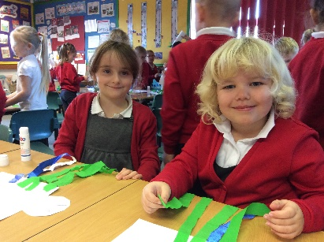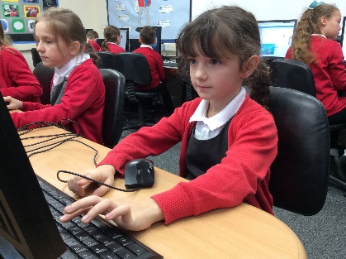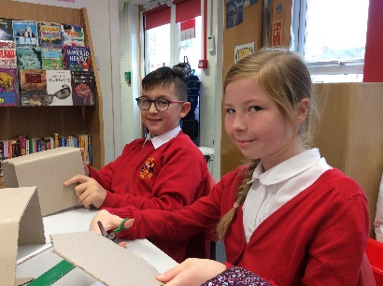

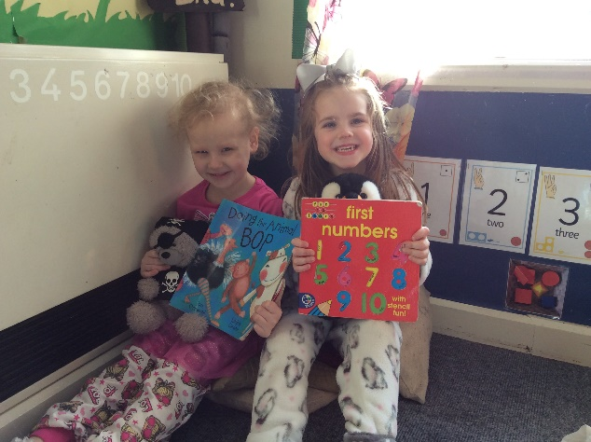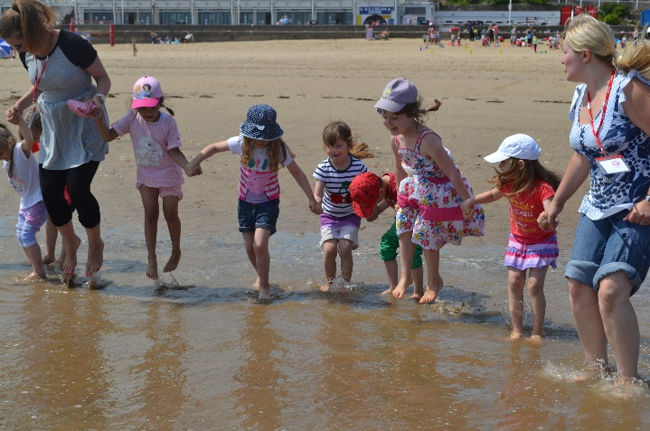
WORLD BOOK DAY EYFS VISITING BRIDLINGTON

Parents as Partners in Learning
There are many ways in which our school encourages parental/carer involvement in children’s learning, namely: supporting reading at home, learning times tables and homework activities. We are also keen for parents to join us for termly open classrooms, parents’ consultation evenings, assemblies, concerts, fayres/ fundraising and house team events, which we hold throughout the academic year.

Foundation Stage
The children in the nursery and reception follow the Early Years Foundation stage guidance, specifically designed for children in their early years of education. They are taught through play and their activities are based around first-hand experiences and experiential learning. They are encouraged to be enquiring, inquisitive and independent learners. There are a number of teacher-led activities in our EYFS unit, including phonics, number work and writing, whilst others are child-initiated, including the outdoor area, water tray and reading corner. Children learn across all areas of the EYFS curriculum to ensure they get off to a flying start in their education and progress in school.

Key Stages 1 and 2
The children from Years 1 to 6 are taught the National Curriculum. The subjects are: Literacy, Mathematics, Science and Computing, Art & Design, Geography, History, MFL, Music and PE. In addition, Religious Education. British Values, SMSC and Personal, Social, Health and Citizenship Education also form an integral part of our school curriculum.

While coverage of the National Curriculum forms an essential part of our work, our aim is to consider the all-round development of the children and, therefore, we place equal emphasis on developing the personal and social skills of our children through the Jigsaw PSHCE programme, programme of assemblies and our trips and visits schedule.

The children will be taught using a variety of different techniques including whole class, small/large groups and individual, 1:1 sessions. We treat all our children as individuals and prepare suitable work accordingly.

7. Other Curriculum Information

Relationships and Sex Education

The school endorses the local authority guidelines and follows the Jigsaw Scheme of Work for Relationships and Sex Education
- Relationships and Sex education forms part of a whole programme of health education within a moral framework.
- The health education programme forms an integral part of the school’s curriculum.
- Relationships and Sex education is taught in mixed ability groups but there will be times when it is more appropriate to teach single groups and/or according to gender.
- Parents are made aware of the content of the school’s Relationships and Sex education programme and are encouraged to discuss this content with the staff and governors where necessary.
- The school makes use of support agencies, e.g. the School Health Service, in delivering the sex education programme.

SEND
We are ambitious far all our pupils at Paisley, and we aim to give every pupil the opportunity to succeed in their learning and to achieve as high a standard as possible across the curriculum. Our teachers adapt learning, where appropriate, to ensure that all pupils make good progress and retain core knowledge across all national curriculum subjects. Support will be offered to children and their families by the Special Educational Needs Coordinator, (SENDCo), in conjunction with the class teacher. Teaching Assistants will also support any child on the SEND register at identified times during the school day. Every child on the special needs register has a One Page Profile and IEP – an individual education plan. Targets are discussed and reviewed in conjunction with the child and parent. The name of the senior member of staff having responsibility for SEND is Ms Collette Lee, the Special Educational Needs Co-ordinator/Phase Leader, supported by the Head of School and Deputy Headteachers.

Child Protection & Safeguarding
Care of our children is the collective responsibility of all the staff. Mrs Hoy is the school’s Designated Safeguarding Lead and our Deputy Safeguarding Lead is Mrs Juggins. The strategic safeguarding leader is Mr Danson. We are required by law to report any concerns we may have to the Social Care, where it appears a child may have been subject to abuse or harm.

Photograph Permission and Internet Safety
Information on internet safety is passed to every parent/carer and child on entry to the school. Forms for completion regarding internet safety are completed by both the child and parent. The school also seeks permission from every parent for their child to be photographed, be it for educational or media purposes, on entry to the school. No photographing or videoing by parents is permitted during whole-school events: i.e., assemblies, concerts and sports days. Regular e-safety training and updates are provided for children, parents and other stakeholders, delivered by our Designated Safeguarding Leads, Mrs. Hoy and Mrs Juggins. E-safety information is available for all parents from the school office and on our website.

PREVENT
All staff have received PREVENT training from the Home Office and through the Safeguarding Network, aimed at the prevention of extremism and radicalisation. Information for parents is available on our website.

Operation Encompass
We are an Operation Encompass school. This is a project between schools and the local police force. It ensures that the school is immediately made aware of any child, who may have been exposed to and/or involved in any domestic incident.

Assessment
This is an integral and essential part of our teaching and learning and is carried out on a continuous and daily basis. Good, robust teacher assessment identifies each child’s strengths and weaknesses then identifies the next steps in the learning process.

In addition to this, statutory, formal assessments are completed at the end of each phase of learning, namely Foundation Stage II, Year 2 and Year 6. Optional assessments are carried out biannually, in line with the Trust testing schedule. Parents are informed of children’s progress, achievement and attainment at autumn and spring term consultation events and in the annual written report.

Religious Education and Collective Worship
The school follows the LA’s Agreed Syllabus for Religious Education. Although the subject is available for all children, the school will make arrangements for parents to exercise their right of withdrawal of their children from Religious Education. The RE curriculum is non-denominational. We have an act of Collective Worship everyday, as whole school or in Phase, year groups or classes. There may be a discussion and often there is time for reflection. If you wish your child to be withdrawn from these assemblies, please contact your child’s teacher or the Head of School to discuss this further.

Homework
We greatly value parents support of homework and, in line with Government recommendations, we have produced a Homework policy, a copy of which is available from the school office or our website.

Educational Visits and Extra Curricular Activities
Educational visits play a very important part in the school’s curriculum and are an important feature of our school life. For some visits, you may be invited to contribute towards the cost of the visit but all visits are subsidised by pupil premium and significant fund-raising throughout the year.

We have a wide selection of after school extra-curricular clubs. Some of these clubs are run by outside agencies and sports clubs provide additional activities, but most are led by Paisley school staff. There are a number of clubs and activities arranged for after school. These are supervised and arranged by staff and include Football, Boxing, Gardening, Cricket, Film, Table Tennis, Craft and the Choir. Letters are sent out by the teachers when these and future clubs are taking place/arise.

8. General Information

Illness
There are a number of staff trained in first aid and paediatric first aid. Mrs. Maundrill is the principal first aider. If your child becomes unwell or injures themselves at school, we will make them as comfortable as possible until we are able to contact you. It is extremely important that we have your current address and telephone numbers. Please ensure that you provide at least 2 mobile phone numbers as your emergency contacts and that they can be reachable during the school day. It is vital that you remember to tell us if any of these details change so that we can always reach you as quickly as possible.

Medicines
For safety reasons we prefer not to have medicines in school, but there are obviously times when this is unavoidable. If your child suffers from asthma you must notify the school and provide the school with an inhaler in the prescribed box. For further information, please refer to our Asthma Policy available on the school website or by hard copy from the school office. If your child has any condition requiring prescribed medication whilst at school, please discuss this with the school office. We will ask you to complete an authorisation form for every medicine your child needs to take whilst they are at school. Medicines should be brought to the school office by the parent/carer. If medicines have to be administered during the course of the school day, you will be required to sign a form, indicating the dosage administered of the medicine. This will be done through the school office. All medicines will be stored safely in the first aid room. Parents should state an optimum time for administration of medicine. Although every effort will be made to administer medicine at that time, medical emergencies would take priority and medicine would be administered as close as possible to the agreed time. The school does not administer non-prescribed medication. For further details, please see our first aid policy and children with medical needs policy.

Sun Protection
In sunny weather children may wear a sunhat. It is preferable that 24-hour sun-cream is applied before the school day. However, sun-cream may be brought to school but this must be labelled and it is the child who applies the sun-cream, as required/indicated by the parent.

Celebrations / Home Baking
We do like to celebrate children’s birthdays in school. Due to health and safety and the variety of dietary restrictions and allergies in school, all cakes and buns which the children may wish to share with the class must be shop-bought and we will distribute them at the end of the school day, allowing the children to take them home with them. In our Friday Gold Book assembly, we sing the happy birthday song to ensure that every child in school is able to celebrate their birthday in the traditional manner with their peers.

Attendance / Absence / Punctuality
We work closely with families to ensure that every child’s attendance in school is as high as it can be. We know we can achieve this with your help and co-operation. The school works very closely with its Educational Welfare officer and monitors punctuality and attendance on a daily basis. We now operate a graduated approach to managing attendance, including setting up attendance support plans and arranging meetings with parents/carers to support families to improve attendance and reduce persistent absenteeism. The school recognises and rewards good attendance as follows as a part of the house teams system.

We have a system for checking absences each day. If your child is unable to attend school for any reason, please contact the school before 9.15a.m. on 355984 for the absence to be noted. If you do not contact us, we will telephone you to determine the reason for your child’s absence and, where possible, the specific nature of the illness must be given. Please try to make routine appointments and check-ups during school holidays or before/after school hours.

In accordance with policy, no term-time holidays will be authorised, unless there are exceptional circumstances. These are defined in the Attendance Policy available on the school website or in hard copy form from the school office. Repeated incidences of lateness and/or unauthorised absenteeism may also incur a further fixed penalty notice and result in EWO intervention.

School Health Service
Children are usually given a medical check during their time at primary school. You will be invited to attend to discuss any medical concerns you may have. Hearing, height and weight checks are carried out by the school nurse and vision checks are carried out by the NHS Child Health Department. If you have any concerns regarding your child’s health, please contact the school office, who will be able to put you in touch with the school nurse. Whole-school dental assessments also take place over the academic year.

Nail Polish
Nail polish must not be worn in school at any time.

Charging Policy
A copy of our Charging Policy is available from the school office or our website.

Contact with the school
The school may contact parents via telephone or letter, in addition to our text-alert messaging system and social media platforms (Facebook and Twitter). It is important that parents keep the school informed of any changes in mobile phone numbers and any other information, emergency contacts, etc., held on your child’s office-held record.

Concerns and Formal Complaints Procedures
Concerns
If you have any concerns regarding your child’s education or school-related matter, this should initially be discussed with your child’s class teacher. If you are still concerned after talking to the teacher, you can make an appointment to see a senior leader. If you are still concerned , you can make an appointment to discuss the situation with the Head of School.

Formal Complaints
If you wish to make a formal complaint, this should be made, in writing, to the Head of School, via the school office. The Head of School will respond, within 5 working days. If the issue remains unresolved after communication with the Head of School, a complaint should then be made, in writing, to the Chair of Local Advisory Board (Miss Josie Speck), via the school office.

We will do all we can to resolve any problems and to ensure that you are happy with the education and provision your child receives in our school.

