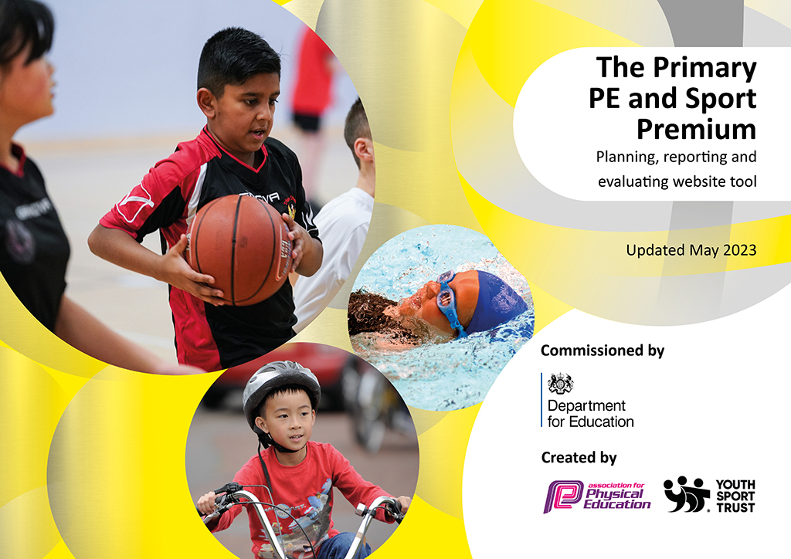
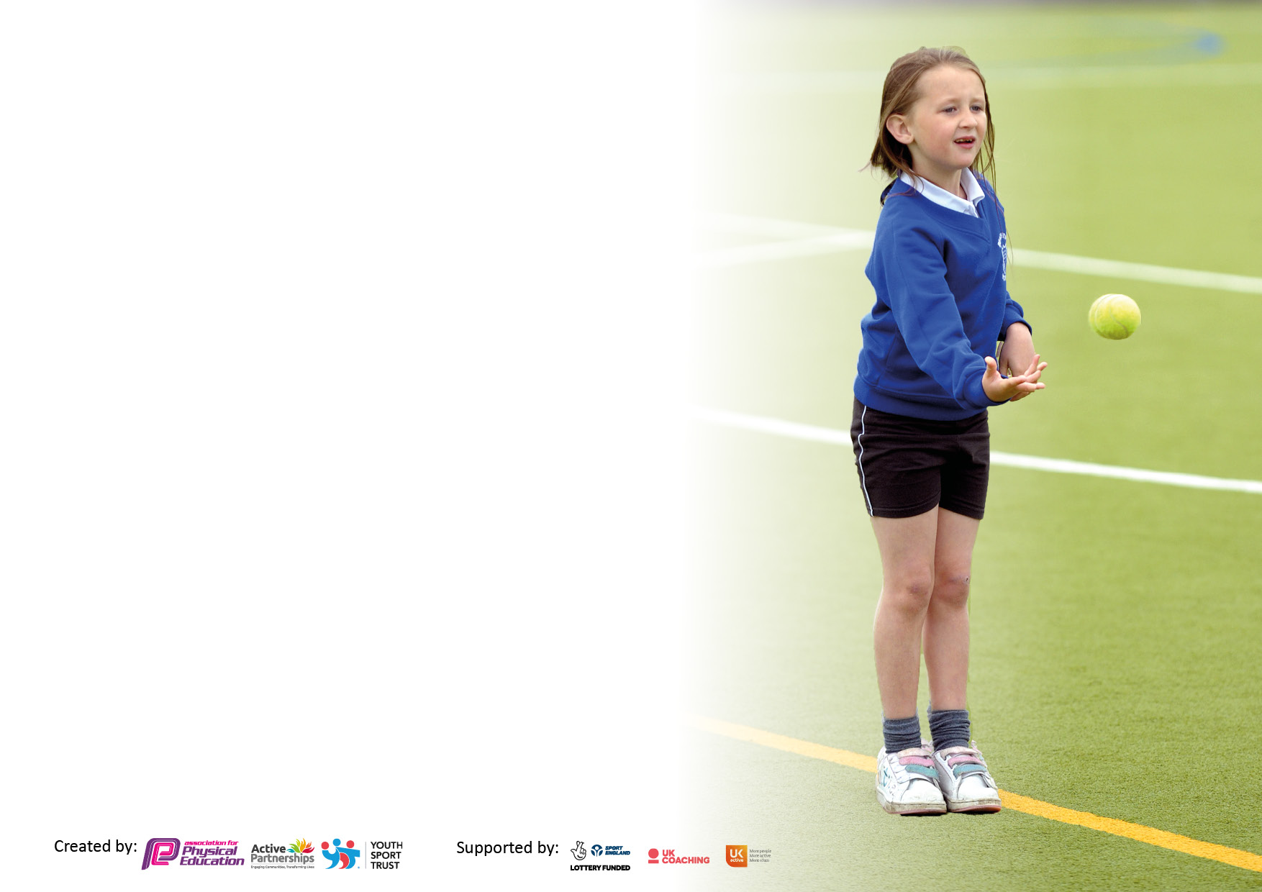

It is important that your grant is used effectively and based on school need. The Education Inspection Framework makes clear there will be a focus on ‘whether leaders and those responsible for governors all understand their respective roles and perform these in a way that enhances the effectiveness of the school’.

Under the Quality of Education Ofsted inspectors consider:
Intent - Curriculum design, coverage and appropriateness
Implementation - Curriculum delivery, Teaching (pedagogy) and Assessment
Impact - Attainment and progress

To assist schools with common transferable language this template has been developed to utilise the same three headings which should make your plans easily transferable between working documents.

Schools must use the funding to make additional and sustainable improvements to the quality of Physical Education, School Sport and Physical Activity (PESSPA) they offer. This means that you should use the Primary PE and sport premium to:

- Develop or add to the PESSPA activities that your school already offer
- Build capacity and capability within the school to ensure that improvements made now will benefit pupils joining the school in future years
- The Primary PE and sport premium should not be used to fund capital spend projects; the school’s budget should fund these.

Please visit gov.uk for the revised DfE guidance including the5keyindicatorsacrosswhichschoolsshoulddemonstrate an improvement. This document will helpyoutoreviewyourprovisionandtoreportyourspend.DfEencouragesschools to use this template as an effective way of meeting the reporting requirements of the Primary PE and Sport Premium.

We recommend you start by reflecting on the impact of current provision and reviewing the previous spend.

Schools are required to publish details of how they spend this funding, including any under-spend from 2021/2022, as well as on the impact it has on pupils’ PE and sport participation and attainment. The funding should be spent by 31st July but the DfE has stated that there will be no clawback of any unspent money so this can be carried forward into 2023/24.

We recommend regularly updating the table and publishing it on your website throughout the year. This evidences your ongoing self-evaluation of how you are using the funding to secure maximum, sustainable impact. Final copy must be posted on your website by the end of the academic year and no later than the 31st July 2023. To see an example of how to complete the table please click HERE.

Details with regard to funding
Please complete the table below.

Total amount carried over from 2021/22 | £n/a
Total amount allocated for 2021/22 | £n/a
How much (if any) do you intend to carry over from this total fund into 2022/23? | £n/a
Total amount allocated for 2022/23 | £19,000.00
Total amount of funding for 2022/23. Ideally should be spent and reported on by 31st July 2023. | £ 19,000.00
Swimming Data
Please report on your Swimming Data below.

Meeting national curriculum requirements for swimming and water safety.

N.B. Complete this section to your best ability. For example you might have practised safe self-rescue techniques on dry land which you can then transfer to the pool when school swimming restarts.
Due to exceptional circumstances priority should be given to ensuring that pupils can perform safe self rescue even if they do not fully meet the first two requirements of the NC programme of study
What percentage of your current Year 6 cohort swim competently, confidently and proficiently over a distance of at least 25 metres?  N.B. Even though your pupils may swim in another year please report on their attainment on leaving primary school at the end of the summer term 2023.  Please see note above | 80%
What percentage of your current Year 6 cohort use a range of strokes effectively [for example, front crawl, backstroke and breaststroke]?  Please see note above | 68%
What percentage of your current Year 6 cohort perform safe self-rescue in different water-based situations? | 80%
Schools can choose to use the Primary PE and sport premium to provide additional provision for swimming but this must be for activity over and above the national curriculum requirements. Have you used it in this way? | No

Action Plan and Budget Tracking
Capture your intended annual spend against the 5 key indicators. Clarify the success criteria and evidence of impact that you intend to measure to evaluate for pupils today and for the future.

Academic Year: 2022/23 | Total fund allocated: | Date Updated:
Key indicator 1: The engagement of all pupils in regular physical activity – Chief Medical Officers guidelines recommend that primary school pupils undertake at least 30 minutes of physical activity a day in school |  |  |  | Percentage of total allocation:
 |  |  |  | 23%
Intent | Implementation |  | Impact
Your school focus should be clear what you want the pupils to know and be able to do and about  what they need to learn and to  consolidate through practice: | Make sure your actions to achieve are linked to your intentions: | Funding allocated: | Evidence of impact: what do pupils now know and what can they now do? What has changed?: | Sustainability and suggested next steps:
- To encourage children to engage in meaningful lunchtime play and activity through OPAL Play initiative.  - To provide high quality additional PE sessions through Tigers Trust Sports coaching..  - To provide extra curriculum PE clubs both on a lunchtime and after school through Tigers Trust, outside specialist & increased staff participation.  - Promote physical activity at home through ModeShift Stars activities (Big Walk).  - Ensure children have access to age appropriate active travel training in order to encourage them to walk (Y3 pedestrian skills training) or cycle to school safely (Y5). | - Provide sustainable, durable equipment for use at lunchtime to facilitate play for children on the field and playground across all phases.  - Sports coach to work with each half-termly on a ‘rota’ basis for addition PE input above national expectations.  - Lunchtime supervisors receive CPD from our sports coach/OPAL play Inset to help them keep children active at lunchtime.  - Teachers and assistants provide extra clubs (football, tag rugby, hockey, scooter, multisport, cricket, rounders, dance, table tennis).  - Reception children take part in balance/scooter training & cheerleading.  - Whole school participation in Walk to School month & Big Walk/cycle initiative (shared with stakeholders in the community)  - Y5 children take part in Bikeability level 1 and 2 training to learn how to ride their bike safely on the road  - Y3 children to take part in pedestrian skills training to learn how to cross roads safely. | £4,500.00 | - Children are actively engaged in meaningful activities during their free play at lunch time, facilitated by the use of appropriate equipment.  - Children are active more regularly at school due to extra PE time and due to the presence of sports leaders on a lunchtime.  - Children are more physically active and skill level improves in certain areas due to the extra clubs they are welcome to access.  - More families are becoming active at home and understand the educational and health benefits. | - PE equipment is constantly being up dated and this will be continued  - Continue to promote the culture within the school community that our school is an ‘Active School’.  - Raise the profile of the importance of PE, school sport and physical activity  - Ensuring parents and families know that PE is as important as any other subject.
Key indicator 2: The profile of PESSPA being raised across the school as a tool for whole school improvement |  |  |  | Percentage of total allocation:
 |  |  |  | 8%
Intent | Implementation |  | Impact
Your school focus should be clear what you want the pupils to know and be able to do and about  what they need to learn and to  consolidate through practice: | Make sure your actions to achieve are linked to your intentions: | Funding allocated: | Evidence of impact: what do pupils now know and what can they now do? What has changed?: | Sustainability and suggested next steps:
- To develop leadership skills in children  - To raise the profile of Physical Education to all children in school.  - Develop life skills in pupils | - OPAL play lead/sports lead to train up House leaders in year 6 who then help at events such as Sports Day & other inter/intra sports events.  - Subject leader attend training provided by Hull Active Schools & Modeshift Star  - Updated curriculum plan to include life skills within PE (GetSet4PE) | £1,500.00 | - Children engage in lunchtime to develop their own physical literacy and skill base. | - Sports leaders/teachers continue to access the CPD materials in the GetSet4PE resources.  - To enroll with Hull Active Schools & Modeshift again next year and continue to access their CPD were appropriate

Key indicator 3: Increased confidence, knowledge and skills of all staff in teaching PE and sport |  |  |  | Percentage of total allocation:
 |  |  |  | 35%
Intent | Implementation |  | Impact
Your school focus should be clear | Make sure your actions to | Funding | Evidence of impact: what do | Sustainability and suggested
what you want the pupils to know | achieve are linked to your | allocated: | pupils now know and what | next steps:
and be able to do and about | intentions: |  | can they now do? What has
what they need to learn and to |  |  | changed?
consolidate through practice:
- To offer more specialist PE teaching to children within school.  - To upskill class teachers with PE games. | - Employ an external sports coach (GetSet4PE) to work with identified classes to provide high quality PE. Teacher’s will accompany the coach to oversee the lessons and gain training during these sessions.  - Specialist sports coaches for extra-curricular clubs (dance, tag rugby, table tennis).  - Class teachers to access GetSet4PE CPD resources (video clips/animations). | £6,660.00 | - Children have increased their own skill levels across a range of sporting activities which will enable them to participate at a higher level.  - Class teachers have a wide breadth of knowledge and ideas for delivering fast, easy and effective activities to their class. | - Works extremely well, the standard of PE taught within school because of this is high. Definite aspect of provision to continue.
Key indicator 4: Broader experience of a range of sports and activities offered to all pupils |  |  |  | Percentage of total allocation:
 |  |  |  | 27%
Intent | Implementation |  | Impact
Your school focus should be clear | Make sure your actions to | Funding | Evidence of impact: what do | Sustainability and suggested
what you want the pupils to know | achieve are linked to your | allocated: | pupils now know and what | next steps:
and be able to do and about | intentions: |  | can they now do? What has
what they need to learn and to |  |  | changed?:
consolidate through practice:
- To ensure that equipment is updated to provide the best experiences for children to participate in a range of activities, both curricular and extra-curricular.  - To ensure that all children enjoy some form of sport or physical activity. | - Update PE equipment which becomes old and damaged to ensure it provides sustainability for purpose and activity.  - Clubs including multi skills, dancing, football, rounders, table, tennis are all on offer to children weekly.  - Taster sessions for clubs such as cheerleading take place to ensure children know where they can participate in activity outside of school.  - Take part in Hull Active Schools programme of competition and development days.  - Maintain a register of pupils accessing extra-curricular clubs & ensuring PP pupils have priority.  - PP, vulnerable & SEND pupils given priority to participate in Hull Active Schools events. | £5,200.00 | - Children have access to high quality equipment to facilitate progress and enjoyment within PE, allowing the enhancement of skills in a broad range of sports.  - The children enjoy and engage in lots of physical activity at festivals.  - Children have and increased awareness of different activities outside of school. | - Equipment is well up to date. A future next step would be to purchase some more basketball equipment (to be ordered Sept ’23).  - We now have a wide range of extracurricular clubs on offer, ran by school staff and specialists.  - Follow on celebration assemblies & social media exposure after festivals/competitions ensure maximum impact from the event.

Key indicator 5: Increased participation in competitive sport |  |  |  | Percentage of total allocation:
 |  |  |  | 6%
Intent | Implementation |  | Impact
Your school focus should be clear | Make sure your actions to | Funding | Evidence of impact: what do | Sustainability and suggested
what you want the pupils to know | achieve are linked to your | allocated: | pupils now know and what | next steps:
and be able to do and about | intentions: |  | can they now do? What has
what they need to learn and to |  |  | changed?:
consolidate through practice:
- Increase participation in sporting competitions and festivals accessible to all children | - Continue membership of the Hull Active Schools/School Games Partnership which in turn offers a range of sporting competitions and festivals.  - Contribute to transport to and from such activities in order that this does not prohibit participation | £1,200.00 | - The skill level of children continues to develop by allowing them to apply those which have been taught into a competitive context.  - All children have the opportunity to compete at intra competitions in preparation for inter competitions.  - Links between school and home improve as families and parents understand and enjoy the high profile we place on PE | - Participation in competitions outside of school this year has been fantastic; Rainbow run, Futsal, Active English, Active Maths, Hull Gotta Dance etc.  - Children access out of school clubs supported by parents.

Signed off by
Head Teacher: | J Danson
Date: | 21.7.2023
Subject Leader: | A Hayward
Date: | 21.7.2023
Governor: | J Speck
Date:

