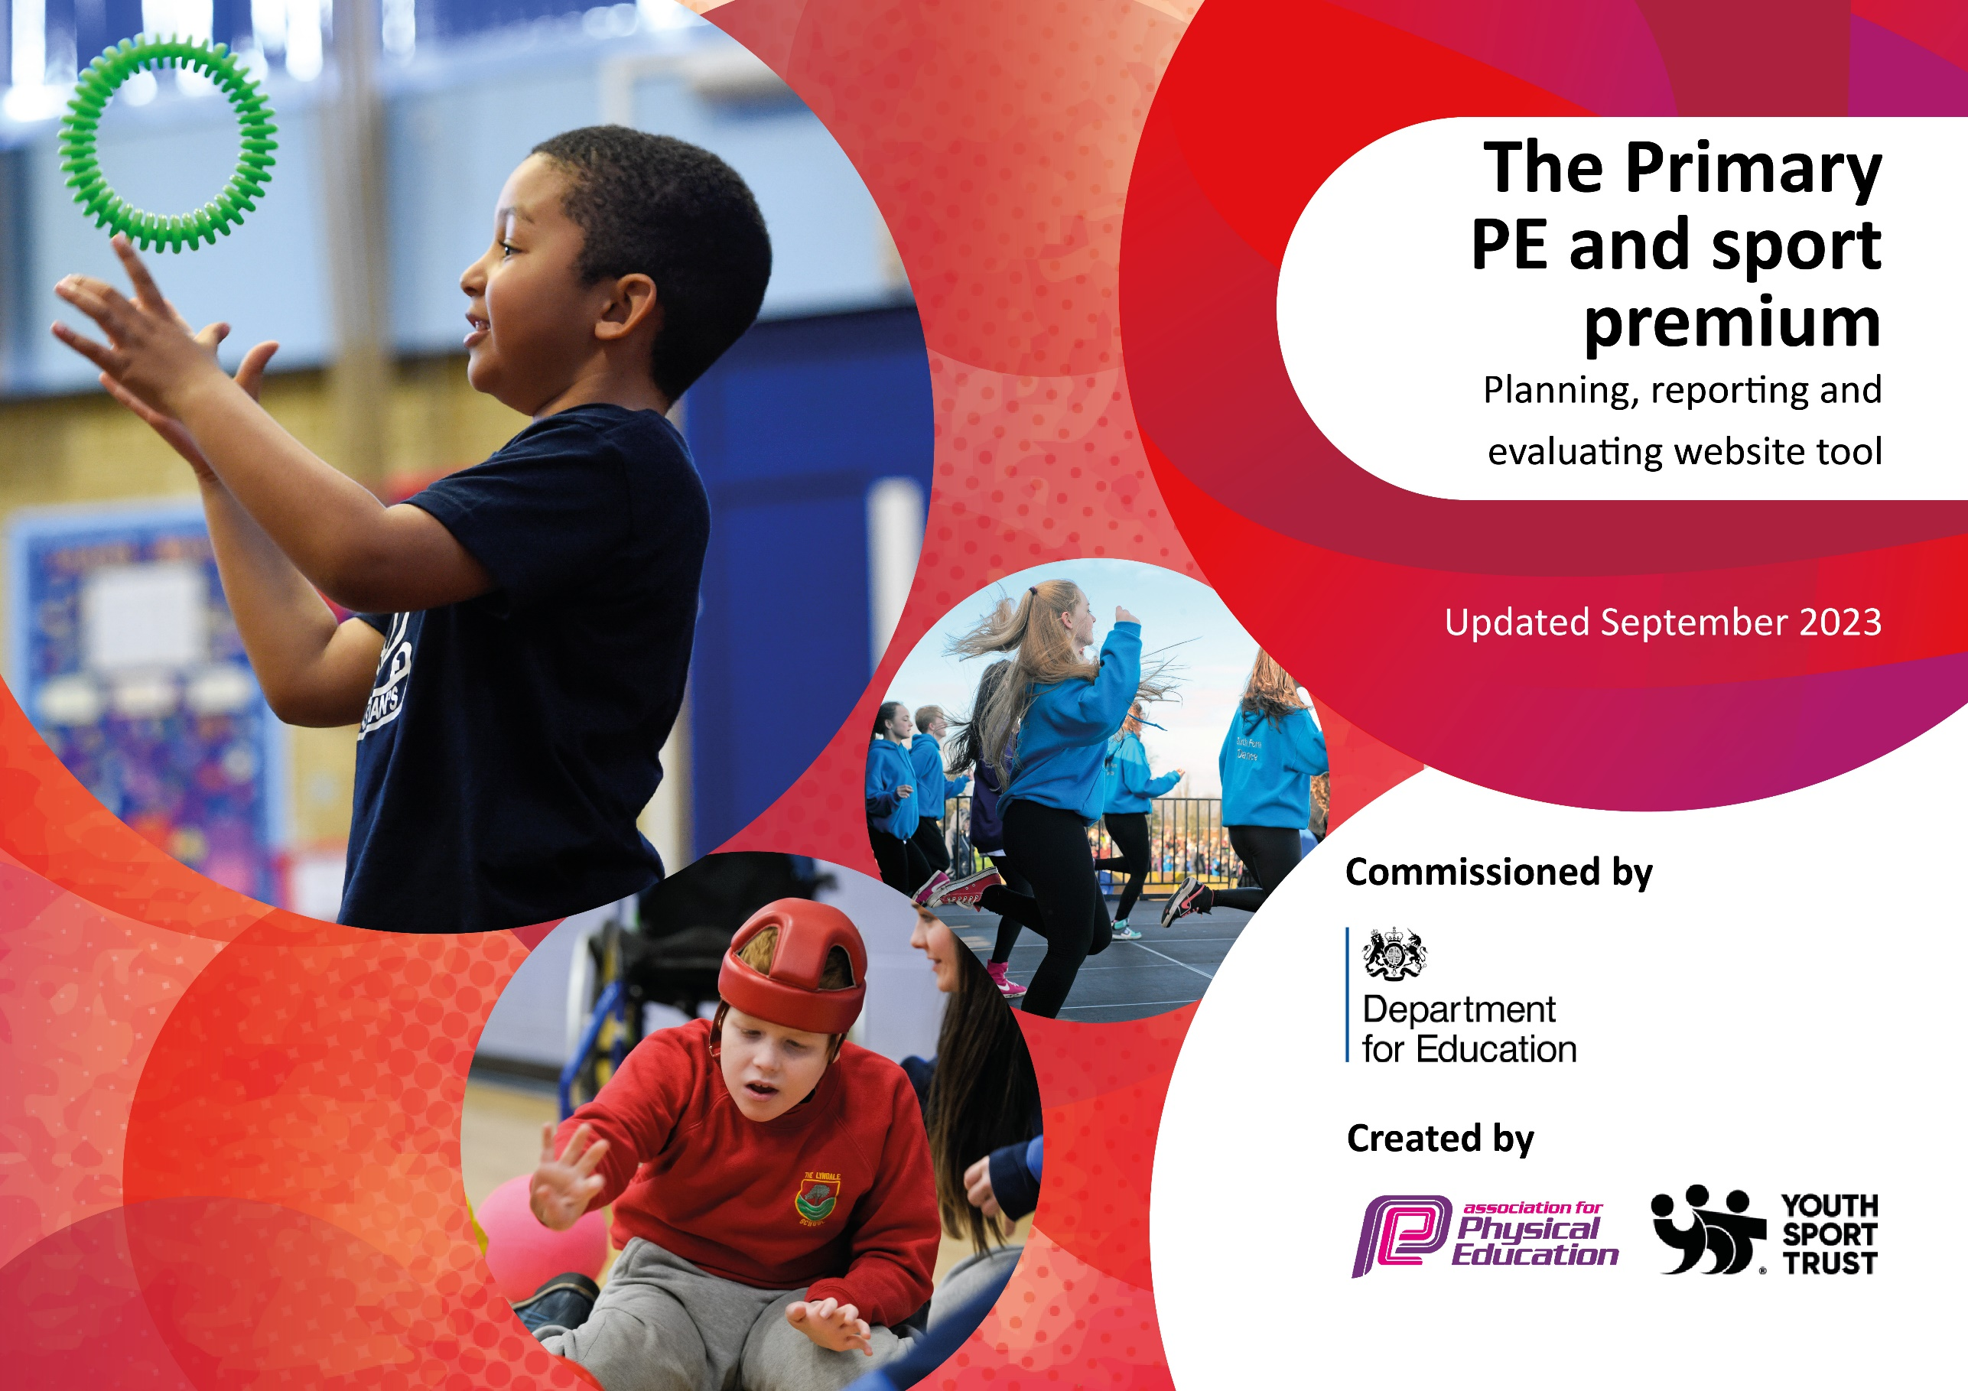

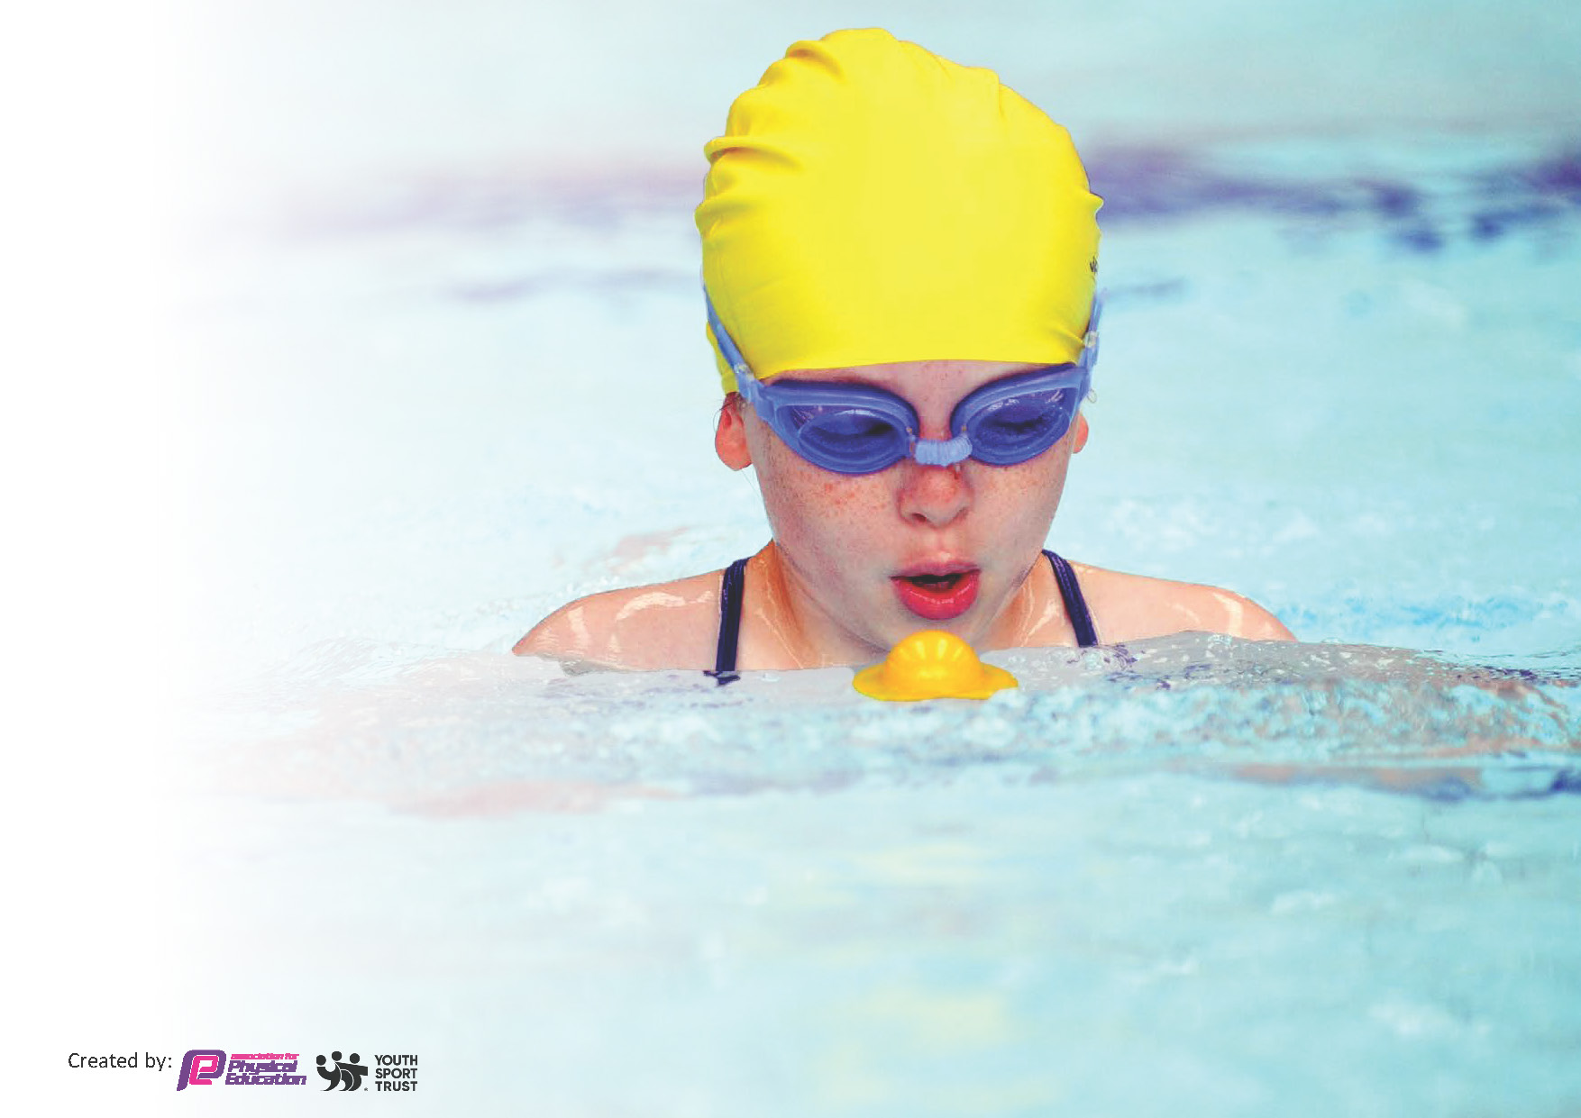
This template can be used for multiple purposes:
by:
- It enables schools to effectively plan their use of the Primary PE and sport premium
- It helps schools to meet the requirements (as set out in guidance) to publish information on their Primary PE and sport premium
- It will be an effective document to support Ofsted inspections enabling schools to evidence progress in Physical Education (PE) and evidence swimming attainment, which forms part of the PE National Curriculum. We would recommend schools consider
the Intent, Implementation and Impact of any spend, as examined within the Education Inspection Framework.

It is important that your grant is used effectively and based on school need.

Schools must use the funding to make additional and sustainable
improvements to the quality of the PE, School Sport and Physical Activity (PESSPA)
they offer. This means that you should use the Primary PE and sport premium to:

- Build capacity and capability within the school to ensure that improvements made now will benefit pupils joining the school in future years
- Develop or add to the PESSPA activities that your school already offers.

The Primary PE and sport premium should not be used to fund capital spend projects; the school’s core budget should fund these. Further detail on capital expenditure can be found in the updated Primary PE and sport premium guidance.

The Primary PE and sport premium guidance, outlines 5 key priorities that funding should be used towards. It is not

necessary that spending has to meet all the key priorities, you should select the priorities that you aim to use any funding towards.

Although completing this template is not a requirement for schools, schools are required to publish details of how they spend this funding. Schools must also outline what the impact this funding has had on pupils’ PE and sport participation and attainment and how any spending will be sustainable in the future. All funding must be spent by 31st July 2024.

The Department for Education has worked closely with the Association for Physical Education (afPE) and the Youth Sport Trust (YST) to develop this template and encourages schools to use it. This template is an effective way of meeting the reporting requirements of the Primary PE and sport premium.

Key priorities and Planning
This planning template will allow schools to accurately plan their spending.

Action – what are you planning to do | Who does this action impact? | Key indicator to meet | Impacts and how sustainability will be achieved? | Cost linked to the action
To encourage children to engage in meaningful lunchtime play and activity through OPAL Play initiative.  To provide high quality additional PE sessions through First Step Sports coaching..  To provide extra curriculum PE clubs both on a lunchtime and after school through First Step Sports, outside specialist & increased staff participation.  Promote physical activity at home through ModeShift Stars activities (Big Walk).  Ensure children have access to age appropriate active travel training in order to encourage them to walk (Y3 pedestrian skills training) or cycle to school safely (Y5). | Provide sustainable, durable equipment for use at lunchtime to facilitate play for children on the field and playground across all phases.  Sports coach to work with each half-termly on a ‘rota’ basis for addition PE input above national expectations.  Lunchtime supervisors receive CPD from our sports coach/OPAL play Inset to help them keep children active at lunchtime.  Teachers and assistants provide extra clubs (football;l, tag rugby, hockey, scooter, multisport, cricket, rounders, dance, table tennis).  Reception children take part in balance/scooter training & cheerleading.  Whole school participation in Walk to School month & Big Walk/cycle initiative (shared with stakeholders in the community)  Y5 children take part in Bikeability level 1 and 2 training to learn how to ride their bike safely on the road  Y3 children to take part in pedestrian skills training to learn how to cross roads safel | Key indicator 1: The engagement of all pupils in regular physical activity – Chief Medical Officers guidelines recommend that primary school pupils undertake at least 30 minutes of physical activity a day in school | engaged in meaningful activities during their free play at lunch time, facilitated by the use of appropriate equipment.  Children are active more regularly at school due to extra PE time and due to the presence of sports leaders on a lunchtime.  Children are more physically active and skill level improves in certain areas due to the extra clubs they are welcome to access.  More families are becoming active at home and understand the educational and health benefits. | £4500.00

To develop leadership skills in children  To raise the profile of Physical Education to all children in school.  Develop life skills in pupils | OPAL play lead/sports lead to train up House leaders in year 6 who then help at events such as Sports Day & other inter/intra sports events.  Subject leader attend training provided by Hull Active Schools & Modeshift Star  Updated curriculum plan to include life skills within PE (GetSet4PE) | Key indicator 2: The profile of PESSPA being raised across the school as a tool for whole school improvement | Children engage in lunchtime to develop their own physical literacy and skill base. | £1500
To offer more specialist PE teaching to children within school.  To upskill class teachers with PE games. | Employ an external sports coach (GetSet4PE) to work with identified classes to provide high quality PE. Teacher’s will accompany the coach to oversee the lessons and gain training during these sessions.  Specialist sports coaches for extra-curricular clubs (dance, tag rugby, table tennis).  Class teachers to access GetSet4PE CPD resources (video clips/animations). | Key indicator 3: Increased confidence, knowledge and skills of all staff in teaching PE and sport | Children have increased their own skill levels across a range of sporting activities which will enable them to participate at a higher level.  Class teachers have a wide breadth of knowledge and ideas for delivering fast, easy and effective activities to their class. | £6,600
To ensure that equipment is updated to provide the best experiences for children to participate in a range of activities, both curricular and extra-curricular.  To ensure that all children enjoy some form of sport or physical activity. | Update PE equipment which becomes old and damaged to ensure it provides sustainability for purpose and activity.  Clubs including multi skills, dancing, football, rounders, table, tennis are all on offer to children weekly.  Taster sessions for clubs such as cheerleading take place to ensure children know where they can participate in activity outside of school.  Take part in Hull Active Schools programme of competition and development days.  Maintain a register of pupils accessing extra-curricular clubs & ensuring PP pupils have priority.  PP, vulnerable & SEND pupils given priority to participate in Hull Active Schools events | Key indicator 4: Broader experience of a range of sports and activities offered to all pupils | Children have access to high quality equipment to facilitate progress and enjoyment within PE, allowing the enhancement of skills in a broad range of sports.  The children enjoy and engage in lots of physical activity at festivals.  Children have and increased awareness of different activities outside of school. | £5200
Increase participation in sporting competitions and festivals accessible to all children | Continue membership of the Hull Active Schools/School Games Partnership which in turn offers a range of sporting competitions and festivals.  Contribute to transport to and from such activities in order that this does not prohibit participation | Key indicator 5: Increased participation in competitive sport | The skill level of children continues to develop by allowing them to apply those which have been taught into a competitive context.  All children have the opportunity to compete at intra competitions in preparation for inter competitions.  Links between school and home improve as families and parents understand and enjoy the high profile we place on PE | £1200

Key achievements 2023-2024
This template will be completed at the end of the academic year and will showcase the key achievements schools have made with their Primary PE and sport premium spending.

Activity/Action | Impact | Comments
Additional Y5 cohort for swimming lessons to catch-up COVID backlog.  PE kit worn by all pupils – additional PE kits purchased for every phase to provide all children with access to correct kit & be included.  Tigers Trust have worked in every key phase.  Competing in HAS girls FUTSAL tournament.  Sports day – Annual Cup, linked to house teams  Participation in Hull Gotta Dance | Successful – 2024/25 – booked Y5 & Y4 to allow 2025/26 to be back on track with just Y4 needing to access swimming lessons.  All children now wearing correct PE kit  CPD for teachers across the school. High quality delivery of PE across the school.  Noticeable increase in girls playing football alongside boys.  Girls & boys participated – increase in numbers of pupils & number of dances submitted | Albert Avenue pool re-opened – easy access within walking distance.  Parents have shown great support.  2 mini football pitches had to be created in summer term to allow number of children to participate actually could.  Already entered for 2024/25

Swimming Data
Meeting National Curriculum requirements for swimming and water safety.
Priority should always be given to ensuring that pupils can perform safe self-rescue even if they do not fully meet the first two requirements of the National Curriculum programme of study

Question | Stats: | Further context  Relative to local challenges
What percentage of your current Year 6 cohort can swim competently, confidently and proficiently over a distance of at least 25 metres? | Y6 - 56%  Y5 - 74% | Y6 - An anxious cohort, 20% had never previously been swimming
What percentage of your current Year 6 cohort can use a range of strokes effectively [for example, front crawl, backstroke, and breaststroke]? | Y6 46%  Y5 – 60%

What percentage of your current Year 6 cohort are able to perform safe self-rescue in different water-based situations? | 56%
If your schools swimming data is below national expectation, you can choose to use the Primary PE and sport premium to provide additional top-up sessions for those pupils that did not meet National Curriculum  requirements after the completion of core lessons. Have you done this? | No
Have you provided CPD to improve the knowledge and confidence of staff to be able to teach swimming and water safety? | No | Staff have attended the lessons delivered by LA & supported the swimming coaches whenever possible.

Signed off by:

Head Teacher: | J Danson
Subject Leader or the individual responsible for the Primary PE and sport premium: | A Hayward, Assistant Headteacher
Governor:
Date: | 1.8.2024

